Reliability of Color Doppler Ultrasound in the evaluation of testicular lesions

**Dr. Md. Jalal Uddin**

**Student of MD (Radiology and Imaging), Final Part**



**Department of Radiology & Imaging Bangabandhu Sheikh Mujib Medical University, Dhaka, Bangladesh**

# Thesis Approval

This thesis is submitted in partial fulfillment of the requirements for the degree of Doctor of Medicine (MD) in Radiology and Imaging granted by Bangabandhu Sheikh Mujib Medical University (BSMMU), Dhaka, Bangladesh. The work has been carried out in the Department of Radiology and Imaging, BSMMU, from July 2015 to June 2017.

**Acceptance of the thesis has been approved by: Board of Examiners:**

**Convener:**

**Prof. Dr. Md. Enayet Karim**

MBBS, DMRD, FCPS, MD,

Professor and Chairman

Department of Radiology and Imaging Bangabandhu Sheikh Mujib Medical University

**Members:**

1. **Prof. Dr. Salahuddin Al- Azad**

MBBS, DMRD, FCPS,

Course Co-ordinator

Department of Radiology and Imaging, Bangabandhu Sheikh Mujib Medical University, Shahbagh, Dhaka.

1. **Professor Dr. M. Mahbubur Rahman**

MBBS, FCPS, FICS (USA)

Retd. Professor and Head of the Department Department of Radiology and Imaging,

National Institute of Neuro-science and Hospital, Dhaka.

1. **Dr. Md. Shafiqul Islam**

MBBS (Dhaka), D.EPID (London) M.Sc. EPID (London), Ph.D. (Cambrige) Associate Professor

Department of Epidemiology NIPSOM, Dhaka.

………………………...

………………………...

………………………...

………………………...

**Date of approval: 29-08-2017**

# CERTIFICATE

This is to certify that **Dr. Md. Jalal Uddin** has worked on **‘Reliability of Color Doppler Ultrasound in the evaluation of testicular lesions’** This research work was carried out in the Department of Radiology and Imaging, Bangabandhu Sheikh Mujib Medical University, Shahbagh, Dhaka, during the period of July 2015 to June 2017 under my direct supervision. I have gone through this thesis and this thesis is up to my full satisfaction.

##### Guide:

**Prof. Dr. Salahuddin Al- Azad**

MBBS, DMRD, FCPS

Professor

Department of Radiology and Imaging,

Bangabandhu Sheikh Mujib Medical University, Shahbagh, Dhaka.

# DECLARATION

I hereby humbly declare that this research study for the fulfillment of Doctor of Medicine (Radiology and Imaging) titled **‘Reliability of Color Doppler Ultrasound in the evaluation of testicular lesions’** is based on work carried out by me and no part of it has been presented previously to any academic institute or university for any higher degree. The research work was carried out in the Department of Radiology and Imaging, Bangabandhu Sheikh Mujib Medical University, Shahbagh, Dhaka, under guidance of Prof. Dr. Salahuddin Al-Azad**,** MBBS, DMRD, FCPS, Department of Radiology and Imaging, Bangabandhu Sheikh Mujib Medical University, Dhaka.

**Dr. Md. Jalal Uddin**

Student of MD, Final part (Radiology & Imaging) Department of Radiology and Imaging

Bangabandhu Sheikh Mujib Medical University, Dhaka.

## LIST OF CONTENTS

**Sl. no. Title Page No.**

|  |  |  |
| --- | --- | --- |
| **1.** | **INTRODUCTION** | 01 |
| **2.** | **RATIONALE OF THE STUDY** | 11 |
| **3.** | **HYPOTHESIS** | 12 |
| **3.** | **OBJECTIVES** | 13 |
| **4.** | **REVIEW OF LITERATURE** | 14 |
|  | 4.1RELATED PREVIOUS STUDY | 14 |
|  | 4.2 ANATOMY | 18 |
|  | 4.2.1 TESTIS | 18 |
|  | 4.2.2 EPIDIDYMIS | 24 |
|  | 4.2.3 DEVELOPMENT OF TESTIS | 24 |
|  | 4.2.4 DESCENT OF THE TESTIS | 25 |
|  | 4.3. BASIC PRINCIPLE OF ULTRASONOGRAPHY | 25 |
|  | 4.4 DOPPLER SONOGRAPHY | 29 |
| **5.** | **METHODOLOGY** | 34 |
| **6.** | **RESULTS AND OBSERVATIONS** | 39 |
| **7.** | **DISCUSSION** | 50 |
| **8.** | **SUMMARY** | 55 |
| **9.** | **CONCLUSION** | 57 |
| **10.** | **LIMITATIONS** | 58 |
| **11.** | **RECOMMENDATION** | 59 |
| **12.** | **BIBLIOGRAPHY** | 60 |
| **13.** | **APPENDICES** |  |
|  | Appendix-I : Clearance of certificate of Institutional  Review Board (IRB) | xi |
|  | Appendix-II: Data Collection Sheet | xii |
|  | Appendix-III: Consent form for subjects | xiv |
|  | Appendix-IV: Statistical formula | xvii |
|  | Appendix-V: Photographs | xviii |

## LIST OF TABLES

|  |  |  |
| --- | --- | --- |
| **Sl. No.** | **Title** | **Page** |
| Table I | Particular of the patients | 39 |
| Table II | Distribution of the study patients by clinical presentation | 41 |
| Table III | Distribution of the study patients by physical examination | 42 |

Table IV Distribution of the study patients by gray scale feature of

43

testicular lesions.

Table V Distribution of the study patients by CDUS finding of

44

testicular lesions.

Table VI Distribution of the study patients by Color Doppler

45

Ultrasound diagnosis of testicular lesions

Table VII Distribution of the study patients by intervention 46

Table VIII Distribution of the study patients by Final Clinical

Diagnosis of testicular lesion (On the basis of final 47 outcome, FNAC and surgery)

Table IX Comparison between Color Doppler ultrasound diagnosis

48

with Final Clinical Diagnosis of testicular lesion

# LIST OF FIGURES

**Figure No. Title Page No**

Figure 1 Bar diagram shows age distribution of the study

40

patients

Figure 2 Pie chart shows marital status of the study patients 40

Figure 3 Bar diagram shows clinical presentation of the study

41

patients

Figure 4 Bar diagram shows Color Doppler Ultrasound

45

diagnosis of the study patients

Figure 5 Bar diagram shows modality of intervention of the

46

study patients

Figure 6 Bar diagram shows Final Clinical Diagnosis of the

47

study patients

# LIST OF ABBREVIATION

|  |  |
| --- | --- |
| BSMMU | Bangabandhu Sheikh Mujib Medical University |
| CDUS | Colour Doppler Ultrasound |
| CDFI | Color Doppler Flow Imaging |
| CEUS | contrast-enhanced ultrasound |
| FNAC | Fine Needle Aspiration Cytology |
| FSH | Follicle Stimulating Hormone |
| HA | Alternative Hypothesis |
| H0 | Null Hypothesis |
| ICSH | Interstitial Cell Stimulating Hormone |
| MRI | Magnetic Resonance Imaging |
| NPV | Negative Predictive Value |
| PPV | Positive Predictive Value |
| PSV | Peak Systolic Velocity |
| RI | Resistivity Index |
| SPSS | Statistical Package for Social Sciences |
| TE | Tissue Elastography |
| US | Ultrasonography |
| USA | United state of America |

## ACKNOWLEDGEMENTS

On this favorable moment, I would like to express my sincere thanks to all who shared their love, constant encouragement and time, kept me from losing hope, they were involved and helped me in different ways in completing the study.

With profound regards, I would like to express my sincere and heartfelt respect, gratitude and indebtedness to my teacher and guide **Prof. Dr. Salahuddin Al- Azad**, department of Radiology and Imaging, Bangabandhu Sheikh Mujib Medical University (BSMMU) Shahbag, Dhaka. His constant guidance, keen supervision, scholarly support, constructive criticism, valuable suggestions, affectionate advice and whole hearted co-operation made this study possible to be completed.

I am indebted and thankful to **Prof. Dr. Md. Enayet Karim,** Chairman, Department of Radiology and Imaging, Bangabandhu Sheikh Mujib Medical University, Dhaka who always supported me and it would have been difficult on my part to carry out this thesis without his careful attention and encouragement.

I am also indebted and thankful to Prof. Dr. Md. Iqbal Hossain, Department of Radiology and Imaging, Bangabandhu Sheikh Mujib Medical University, Dhaka who always supported me and it would have been difficult on my part to carry out this thesis without his careful attention and encouragement.

I would pay gratitude to Professor Dr. M. Mahbubur Rahman , Retd. Professor and Head of the Department Department of Radiology and Imaging, National Institute of Neuro-science and Hospital, Dhaka., for his advice during the research work.

I would pay gratitude to the Chairman and respected teachers of Department of Surgery, Bangabandhu Sheikh Mujib Medical University, Dhaka, for their assistance and co-operation.

I like to express my gratitude to my respected teachers Dr. Md. Nazrul Islam,Dr.Md. Mainul Ahsan Dr. Bishwajit Bhowmik, Dr. Sayeeda Showkat, Dr. Mahbuba Shirin, Dr. Habiba Khatun, Dr. Shahnaz Chowdhury, department of Radiology and Imaging, BSMMU, Shahbag, Dhaka, for their constant supervision, kind Co-operation, valuable suggestions, helpful criticism and all possible help required for the field work of the study.

I wish to offer my deep gratitude to my teacher Dr. Morsheda Begum, Dr. Mostofa kamal, Dr.Ashish Kumar, Dr. Anindita Datta, Radiology and Imaging department, BSMMU, Dhaka, for their valuable suggestion, assistance and co-operation.

I sincerely thanks to all other respected teachers of my department who gave me there valuable suggestion required for the field work of the study.

I thankfully recall the co-operation of my colleagues, fellow students and medical officers of the department of Radiology and Imaging, BSMMU.

I am thankful to all staff members of the department of Radiology and Imaging, BSMMU for their assistance and co-operation.

Last, but not the least, I am indebted to all my patients for their kind co-operation during the whole period of my study.

**Dr. Md. Jalal Uddin**

Student of MD, Final part (Radiology & Imaging) Department of Radiology and Imaging

Bangabandhu Sheikh Mujib Medical University, Dhaka.

# INTRODUCTION

Ultrasound is a sensitive and accurate technique for the evaluation of testicular abnormalities, and is widely accepted as the first-line imaging technique for many common and uncommon testicular diseases. Ultrasound is effectively the sole scrotal imaging technique that a patient will undergo prior to surgery. Traditionally, B-mode ultrasound is extremely sensitive in the detection of testicular masses, but does not provide histological diagnosis. Although most focal lesions were benign and require an orchidectomy, recognition of the benign entity may be challenging. When clearly implied, with all available ultrasound techniques, that the abnormality is a benign intratesticular process, testis-sparing management options become suitable for patient management. Currently, there are limited ultrasound criteria that allow definitive differentiation of benign from malignant testicular lesions. Although not entirely diagnostic, ultrasound techniques such as colour Doppler ultrasound (CDUS), contrast-enhanced ultrasound (CEUS) and tissue elastography (TE), in addition to B- mode imaging, are available to provide a more detailed interrogation of focal testicular lesions (Huang and Sidhu 2012).

Color Doppler ultrasonography (CDUS) is an important tool for diagnosis of testicular diseases because of its ability to depict anatomy and perfusion in real time (Lerner et al. 1990). Diagnosis of testicular diseases has always been a challenge for the clinician due to non-specific signs and symptoms (Pavlica and Barozzi 2001). The common testicular lesions are torsion, trauma, neoplasms, and inflammatory conditions. Extratesticular lesions include lesions of the spermatic cord, the epididymis, and the scrotal wall. This distinction is important because extratesticular masses are almost always benign while intratesticular solid masses may be malignant.

Ultrasonography plays a major role in distinguishing intratesticular from extratesticular abnormalities. Color Doppler ultrasonography is an excellent, safe, and reliable method for evaluating patients with scrotal diseases (Rizvi et al. 2011).

The use of CDUS in the following testicular abnormalities illustrates the potential of this technique in evaluating testicular lesions.

###### Testicular tumours

Testicular tumours contribute to approximately 1% of all malignancies in males. 90– 95% of malignant intratesticular tumours are primary germ cell tumours. Germ cell tumours arise from spermatogenic cells and are almost uniformly malignant. Germ cell tumours are broadly divided into seminomatous and non-seminomatous types. Non-germ cell tumours represent the remainder of primary and secondary testicular tumours, and are made up of sex cord stromal tumours (Leydig or Sertoli cell tumours), lymphoma and metastasis (Huang and Sidhu 2012).

Seminoma

Seminoma is the most common pure germ cell tumour. It accounts for 35–50% of all germ cell tumours. It occurs in an older population, in comparison with non- seminomatous tumours, with an average patient age of 40.5 years (Woodward et al. 2002). At histology, a seminoma is made of relatively uniform cells with clear cytoplasm and lymphoid infiltrate. On CDUS there is demonstrable vascularity within the lesion.

Non-seminomatous germ cell tumours

Of the non-seminomatous germ cell tumours, mixed germ cell tumours are much more common than any of the pure histological forms. Embryonal carcinoma is the most common component, and is often combined with one or more components of teratoma, seminoma and yolk sac tumour. The imaging findings reflect the diversity of the components of these lesions. On B-mode images these tumours may be inhomogeneous, with areas of increased echogenicity, calcification and cyst formation. Increased vascularity may or may not be demonstrated, and therefore may be mistaken for a benign avascular abnormality,

Non-primary malignant tumours

Non-primary tumours such as lymphoma, leukaemia and metastasis can all manifest as an indeterminate testicular mass. Testicular lymphoma occurs in a much older population than those affected by primary germ cell tumours, and is the most common testicular neoplasm in males over 60 years of age. The epididymis and spermatic cord are commonly involved. Primary leukaemia of the testis is rare; secondary testicular involvement is more common. Sonographic findings in both lymphoma and leukaemia may be represented by focal or multifocal hypoechoic lesions, and may be indistinguishable from germ cell tumours. Correlation to relevant clinical history would be required in reaching correct diagnosis. Other metastases to the testis, which are rarely the presenting complaint, are most commonly seen in cases of widespread primary prostate and lung malignancies (Ulbright et al. 1999).

###### Testicular torsion

Testicular torsion is most common in age group 10–25 years, but it can occur at any age. Prompt diagnosis is necessary because torsion requires immediate surgery to preserve the testis. This initially results in testicular venous outflow obstruction, subsequent engorgement, arterial obstruction, and rapid irreversible testicular infarction, normally within 6 hours of onset (Yusuf et al. 2013). On gray-scale sonography, in acute phase of torsion, within 1–6 hours, testis appears enlarged, with normal echogenicity, and later it becomes heterogeneous and hypoechoic compared with the contralateral normal testis. A hypoechoic or heterogeneous echogenicity may indicate nonviability. Reactive hydrocele and scrotal skin thickening are often seen with torsion. The gray-scale findings of acute and subacute torsion are not specific and may be seen in testicular infarction caused by epididymitis, epididymo-orchitis, and traumatic testicular rupture or infarction (Gorman 2011). Color Doppler sonography shows absent blood flow in the affected testicle (Liang et al. 2013) or significantly less than in the normal, contralateral testicle. The spermatic cord immediately cranial to the testis and epididymis is twisted and intrascrotal portion of the cord appears as edematous, round, ovoid or curled echogenic extra-testicular mass, with the epididymal head wrapped around it causing a characteristic torsion knot or “whirlpool pattern” on color Doppler. Torsion of at least 540° is necessary for complete arterial occlusion. With partial torsion of 360°, or less, arterial flow may still occur, but venous outflow is often obstructed, causing diminished diastolic arterial flow on spectral Doppler examination (Cassar et al. 2008) If spontaneous detorsion occurs, flow within the affected testis may be normal, or it may be increased and mimic orchitis (Gorman 2011 and D’Andrea et al. 2013).

###### Segmental testicular infarction

Segmental testicular infarction is an infrequent finding in patients with acute testicular pain. Predisposing factors to segmental infarction include epididymo-orchitis, trauma, hypersensitivity angiitis, intimal fibroplasia of the testicular artery, previous surgery, polycythaemia and sickle cell disease (Fernandez-Perez et al. 2004). Ultrasound examination demonstrates an area of mixed or low reflectivity, which may be wedge or round shaped (Bilagi et al. 2007). There is poor or absent colour Doppler flow.

Oedema in the infarcted area that displaces the surrounding testicular tissue and causes bundling of the perilesional parenchymal vessels. The ultrasound appearances, the absence of tumour markers and a change in the size or shape of the abnormality during follow-up will often establish the benign nature of the abnormality.

###### Orchitis

Primary orchitis is rare without associated epididymo-orchitis, but may be caused by human immunodeficiency virus or mumps virus. The process may be seen as diffuse or focal. Orchitis may manifest as multiple hypoechoic abnormalities within the testicular parenchyma, with septal accentuation with foci of low reflectivity conforming to the lobular anatomy (Cook and Dewbury 2000). As the condition progresses, areas of venous infarction occur with associated haemorrhage, giving rise to areas of mixed or increased reflectivity. Increased blood flow to the epididymis and testis at CDUS examination is a well-established criterion for the diagnosis of epididymo-orchitis. After treatment and healing, changes may resolve completely, or often there is loss of volume of the testis with fibrosis giving a heterogeneous pattern on ultrasound. The great variability in ultrasound appearances can cause diagnostic

confusion, but awareness of the changes and progression may allow a more confident diagnosis to be made in the appropriate clinical setting.

###### Venous infarction

Venous infarction of the testis may occur in cases of severe epididymo-orchitis where local swelling occludes the venous drainage of portions of the testis or the entire testis. Venous infarction may also occur in patients with hypercoagulable states. On ultrasound the testis is of low or mixed echo reflectivity. There is an absence of colour Doppler flow and contrast enhancement. The diagnosis should also be suspected when reversal of intratesticular arterial flow in diastole is observed with an associated focal abnormality (Sanders et al. 1994).

###### Intratesticular haematoma

A history of trauma should raise the suspicion of the differential of an intratesticular haematoma. Acutely, the haematoma appears as patchy increased reflectivity. On follow-up it may appear as an area of low reflectivity, with reduction in size as the haematoma retracts. The most important differential diagnosis is malignancy, and therefore an accurate history, lack of vascularity on CDUS, absence of tumour markers and reduction in the size of the abnormality on sequential scans is indicative of a benign entity (Purushothaman et al. 2007).

###### Intratesticular abscess

Intratesticular abscesses are unusual and are associated with severe epididymo- orchitis (Stewart & Sidhu 2007). They may also arise secondary to mumps, trauma or infarction. The ultrasound appearances are of a lesion of low reflectivity with

irregular borders. Hypervascular rims may be visible surrounding a testicular abscess on CDUS but no internal vascularity is present. The abnormality observed in testicular abscess does not conform to lobular distribution, which may help to differentiate this from a segmental infarction.

###### Rete testis

The rete testis is a system of numerous seminiferous tubules located at the mediastinum testis, which drain to the epididymal head. On ultrasound the rete testis has a spectrum of appearances ranging from a faintly visible ill-defined area of decreased reflectivity to a coarse tubular appearance with finger-like projection into the parenchyma (Sellars and Sidhu 2001). No vascular flow is demonstrated within rete testis. They may resemble a hypoechoic mass when viewed in cross-section. As long as ultrasound appearances remain typical with no soft tissue component or abnormal colour Doppler signal, no further investigation is usually required. Although this is a benign entity, it may be of significance in a patient suffering from azoospermia as this implies there is obstruction of the ipsilateral spermatic ducts.

###### Testicular sarcoidosis

Involvement of the genital system by sarcoidosis is rare. It more commonly affects the epididymis but can also involve the testis. On ultrasound the lesions of sarcoidosis are typically multiple, small, bilateral low-reflectivity masses. Differentiation from malignancy may be difficult, and clinical evidence of sarcoidosis elsewhere is required for diagnosis to be made more confidently (Stewart & Sidhu 2007). If there are no associated symptoms or features, then ultimately tissue biopsy for pathological evaluation may be required. Post-trauma testicular devascularisation of the testis may

occur following significant traumatic injury to the scrotum. On CDUS little vascular flow was appreciated within the devascularised segment.

###### Simple testicular cyst with debris

Simple cysts are detected incidentally and usually occur in males over 40 years of age, with a size range from 2mm to 2cm in diameter. The cysts are usually solitary, and may be associated with spermatoceles (Dogra et al. 2001). Colour Doppler ultrasound could exclude presence of complex features such as internal vascularity or enhancement.

Color Doppler ultrasonography has many advantages over conventional ultrasonography. In addition to detecting non-specific grey scale changes that can occur with testicular ischemia, it also shows blood flow in testicular arteries. Till recently, radionuclide scanning has played an important role in evaluation of equivocal cases of acute scrotal diseases. It has provided useful information regarding scrotal blood flow (Lutzker & Zuckier 1990). However, it cannot accurately depict the anatomy. Middleton and associates evaluated 28 patients with acute scrotal pain by CDUS and scintigraphy. While CDUS correctly diagnosed all the subjects, scintigraphy failed to reach the diagnosis in one (Middleton et al. 1990). Also CDUS was more rapid, non-invasive, and at least as accurate as scintigraphy (Fitzgerald et al. 1992).

Accurate clinical diagnoses of scrotal diseases are difficult as most patients present with similar signs and symptoms (Pavlica & Barozzi 2001). Color Doppler ultrasonography is currently the most important imaging modality available for

diagnosis of scrotal pathologies. It allows accurate evaluation of scrotal conditions as well as normal anatomy. Becker and coworkers concluded a sensitivity of 90.5% and specificity of 98.3% in diagnosis of testicular torsion (Becker et al. 1997). Suzer and colleagues found CDUS to be 100% sensitive and 100% specific in diagnosis of acute scrotal conditions (Suzer et al. 1997).

However, CDUS is not without pitfalls. Zoller and associates concluded that detection of intratesticular blood flow cannot exclude testicular torsion (Zoller et al. 2000). Derouet and coworkers observed ultrasonography to be 90% sensitive and 55% specific in detection of testicular neoplasms (Derouet et al. 1993) whereas Gallardo Agromayor and colleagues reported sensitivity of 100% for ultrsonography in diagnosing testicular neoplasm (Gallardo et al. 1996). In their study, CDUS showed a sensitivity of 87.5% and specificity of 66.7% in detection of testicular neoplasms, which is compatible with the study carried out by Derouet et al. (1993).

Other investigations like magnetic resonance imaging can be applied when ultrasonography proves inconclusive. Its use in scrotal diseases is increasing; (Terai et al. 2006; Watanabe et al. 2000) however, it is more expensive and not always available. Nuclear scintigraphy, which has high sensitivity and specificity in differentiating ischemia from infarction, cannot accurately distinguish ischemia from conditions such as hydrocele, spermatocele, and inguinal hernia and is uncommon due to high accuracy of CDUS (Lutzker & Zuckier 1990). Therefore, CDUS with its high sensitivity and specificity is the most important investigation for diagnosis of scrotal diseases, presenting especially in emergency clinical setting. But it has its own limitations, including difficulty in detecting intratesticular flow in small children and

requiring adequate expertise and experience (Atkinson et al. 1992). Its results are also equipment dependent. Purpose of this study is to determine the value of Color Doppler ultrasonography (CDUS) as a routine investigational method for diagnosis of testicular pathologies.

# RATIONALE OF THE STUDY

Real-time ultrasound has long been the standard of reference for the evaluation of testicular disorders. Color Doppler ultrasonography (US) is simple, non-invasive and a relatively new modality in testicular imaging that can reliably display normal testicular vascular anatomy. Many studies have described the usefulness of Color Doppler US in differentiating epidymo- orchitis from testicular torsion.

The use of CDUS help to establish the correct diagnosis of a variety of conditions involving testis. Although no ultrasound appearances are entirely diagnostic, features demonstrated with these technologies provide better characterisation of intratesticular lesions. With increasing experience, ultrasound evaluation of testicular pathology may allow a tailored follow-up plan, or targeted ultrasound-guided excision biopsy when deemed appropriate, thus potentially reducing the number of unnecessary orchidectomies.

CDUS can simultaneously display scrotal anatomy and perfusion, is an excellent, a safe, and reliable method for evaluating patients with testicular diseases, whether acute or chronic. It is also convenient and easy to perform. It helps to improve patient’s management, especially by preventing unnecessary surgical exploration.

# Hypothesis

Color Doppler Ultrasonography (CDUS) is a reliable method for the diagnosis of testicular pathologies.

# OBJECTIVES

**General objectives:**

* To evaluate different testicular disease pattern.

**Specific objectives:**

* To find out the reliability of Color Doppler ultrasonography (CDUS) in diagnosis of Testicular lesions.
* To observe clinico- pathological aspects of testicular lesions.

# LITERATURE REVIEW

###### RELATED PREVIOUS STUDY

A series of 7 testicular epidermoid cysts were imaged by contrast-enhanced sonography to assess internal vascularity and by real-time tissue elastography to grade stiffness by a visual and strain ratio quantification scoring system (Patel et al. 2012). No internal vascular enhancement was seen on contrast-enhanced sonography; the 3 largest lesions showed rim enhancement. On the real-time elastographic color display, all lesions were predominantly blue ("hard"), and the lesions analyzed for the strain ratio had a mean value of 43.57. Contrast-enhanced sonography depicts the absence of vascular flow, and real-time elastography shows that the epidermoid cysts are hard. This combination of information will help further characterize these lesions.

Lung et al. (2012) determined the effectiveness of contrast-enhanced ultrasound in evaluating incidental focal testicular lesions in epididymitis. Over 28 months, 16 focal testicular lesions with median lesion size, 24 mm; ranged from 14–48 mm in 14 patients with median age 49 years; ranged from 18–81 years were examined. Lesions were oval (*n*=14), wedge shaped (*n* = 1), or involved the entire testis (*n* = 1). Lesions were isoechoic (*n* = 1), hypoechoic (*n* = 4), or of mixed echogenicity (*n* = 11). Color Doppler ultrasound flow was not clearly depicted in 13 lesions but was present in three lesions, with contrast-enhanced ultrasound concordant with color Doppler ultrasound, showing unequivocal absence of vascularity and increased flow, respectively. In the avascular lesions, rim enhancement (*n* = 6), vascular projections (*n* = 4), and irregular (*n* = 10) and smooth (*n* = 2) borders were documented. The observers identified infarction (*n* = 9), abscess (*n* = 4), orchitis (*n* = 1), and tumor (*n* =

2). Histologic examination (seven lesions in five patients) confirmed infarction, abscess formation, and seminoma; follow-up ultrasound confirmed resolution for eight patients. Contrast-enhanced ultrasound is a useful adjuvant to color Doppler ultrasound examination of a focal lesion in the testis ipsilateral to epididymitis to improve the characterization of nonvascularized tissue.

Rizvi et al. (2011) determined the value of color Doppler ultrasonography (CDUS) as a routine investigational method for diagnosis of scrotal pathologies. Their cross sectional study (case series) was carried out over a period of 16 months on 122 patients in the age range of 13 to 70 years old, who presented with scrotal swellings. The final diagnoses were epididymitis or epididymo-orchitis (46), hydrocele (26), varicocele (16), testicular malignancy (16), orchitis (6), testicular torsion (4), spermatic cord injury (2), hematocele (2), and pyocele (2). Color Doppler ultrasonography accurately diagnosed all cases of epididymitis or epididymo-orchitis, spermatic cord injury, testicular torsion, varicocele, and hydrocele (sensitivity 100% and specificity 100%). Of 16 subjects diagnosed as testicular malignancy on CDUS, only 14 were subsequently found to have malignancy. Two cases of orchitis were wrongly diagnosed as malignancy. Similarly, of 6 patients diagnosed as orchitis, 1 was found to have seminoma (sensitivity 87.5% and specificity 66.7%). Overall sensitivity of CDUS in diagnosing scrotal diseases was 98% while specificity was 66.7%. Color Doppler ultrasonography is an excellent, safe, and reliable method for evaluating patients with scrotal diseases. It aids in diagnosis of testicular tumors and reduces the number of unnecessary exploratory operations. It is especially important in conditions like testicular torsion where immediate diagnosis is required.

Terai et al. (2006) study correlated the magnetic resonance imaging (MRI) diagnosis with the surgical findings and/or clinical outcomes in patients presenting with an acute scrotum.

Bilagi et al. (2007) study analysed the aetiology and ultrasound appearances of segmental testicular infarction. Patients with focal testicular lesions underwent colour Doppler high frequency ultrasound. Segmental testicular infarction was defined as any focal area of altered reflectivity, with or without focal enlargement with absent or diminished colour Doppler flow, proven on histology or on follow-up exclusion of lesion progression. Patients were reviewed to document lesion shape, position, border definition, reflectivity and vascularity and correlated to presenting clinical symptoms and signs. Over a 6-year period 24 patients were defined as having segmental testicular infarction; median age was 37 years with ranged from 16-82 years. All presented with a sudden onset of testicular pain. Of the patients, 58.3% had scrotal inflammatory disease, 20.8% had evidence of spermatic cord torsion, and three patients were termed idiopathic; 50.0% were of low reflectivity, 45.8% of mixed reflectivity, one of high reflectivity, 45.8% were wedge shaped, and 54.2% were round shaped. Of the patients, 33.3% demonstrated a mass effect, all with round- shaped lesions and with underlying epididymo-orchitis in seven. Absent colour Doppler flow was demonstrated in 83.3%. Histology confirmed infarction in 33.3% and 50.0% had follow-up examinations without progression of the lesions. Segmental testicular infarction has characteristic ultrasound features, not always wedge-shaped, with reduced or absent vascularity of key importance. Awareness of the ultrasound features will allow for conservative management and avoid unnecessary orchidectomy.

Varsamidis et al. (2001) determined whether Doppler ultrasonography (US) could be use- ful in the evaluation of testicular neoplasms presenting with acute scrotal pain. A total of 18 patients evaluated, 11 were found to have testicular tumors and 7 testicular inflammation. Peak systolic and end-diastolic velocities significantly increased in patients with testicular tumor (*p*<0.002) and orchitis (*p*<0.01) versus normal controls. Follow-up examination on completion of 1- week antibiotic treatment demonstrated persistent high velocity values in patients with tumor and normalization of velocity values in patients with orchitis. Their results supported the concept that follow-up Doppler US examination is of value in patients with acute scrotal pain submitted to antibiotic treatment since it may contribute to the differentiation between orchitis and testicular tumor.

### ANATOMY

* + 1. **TESTIS**

The testis is the male gonad. It is homologous with the ovary of the female.

It is suspended in the scrotum by the spermatic cord. It lies obliquely, so that its upper pole is tilted forwards and medially. The left testis is slightly lower than the right.

The testis is oval in shape, and is compressed from side to side. It is 3.75 cm long, 2.5 cm broad from before backwards and 1.8 cm thick from side to side. An adult testis weighs about 10 to 15 g. (Garg, 2016)

#### External Features The testis has:

1. Two poles or ends, upper and lower.
2. Two borders, anterior and posterior.
3. Two surfaces, medial and lateral

The upper and lower poles are convex and smooth. The upper pole provides attachment to the spermatic cord.

The anterior border is convex and smooth, and is fully covered by the tunica vaginalis. The posterior border is straight, and is only partially covered by the tunica vaginalis. The epididymis lies along the lateral part of the posterior border. The lateral part of the epididymis is separated from the testis by an extension of the cavity of the tunica vaginalis. This extension is called the sinus of epididymis. The medial and lateral surfaces are convex and smooth. Attached to the upper pole of the testis, there is a small oval body called the appendix of the testis. It is a remnant of the paramesonephric duct (Garg, 2016).

#### Coverings of the Testis

The testis is covered by three coats. From outside inwards, these are the tunica vaginalis, the tunica albuginea and the tunica vasculosa.

The tunica vaginalis represents the lower persistent portion of the processus vaginalis. It is invaginated by the testis from behind and, therefore, has a parietal and a visceral layer with a cavity in between. It covers the whole testis, except for its posterior border.

The tunica albuginea is a dense, white fibrous coat covering the testis all around. It is covered by the visceral layer of the tunica vaginalis, except posteriorly where the testicular vessels and nerves enter the gland. The posterior border of the tunica albuginea is thickened to form an incomplete vertical septum, called the mediastinum testis, which is wider above than below. Numerous septa extend from the mediastinum to the inner surface of the tunica albuginea. They incompletely divide the testis into 200 to 300 lobules.

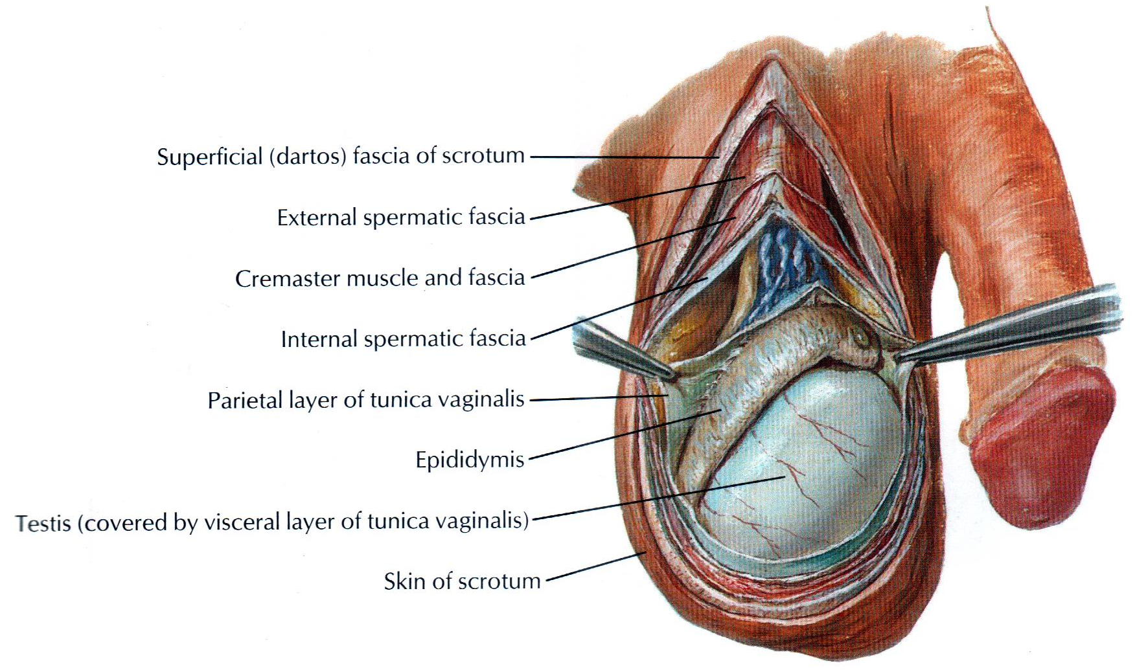The tunica vasculosa is the innermost, vascular coat of the testis lining its lobules (Garg, 2016)

**Figure1: External Genitalia (Netter, 1989).**

#### Structure of the Testis

The glandular part of the testis consists of 200 to 300 lobules. Each lobule contains two to three seminiferous tubules. Each tubule is highly coiled on itself. When stretched out, each tubule measures about 60 cm in length, and is about 0.2 mm in diameter. The tubules are lined by cells which represent stages in the formation of spermatozoa.

The seminiferous tubules join together at the apices of the lobules to form 20 to 30 straight tubules which enter the mediastinum. Here they anastomose with each other to form a network of tubules, called the rete testis. In its turn, the rete testis gives rise to 12 to 30 efferent ductules which emerge near the upper pole of the testis and enter the epididymis. Here each tubule becomes highly coiled and forms a lobe of the head of the epididymis. The tubules end in a single duct which is coiled on itself to form the body and tail of the epididymis. It is continuous with the ductus deferens (Garg, 2016)

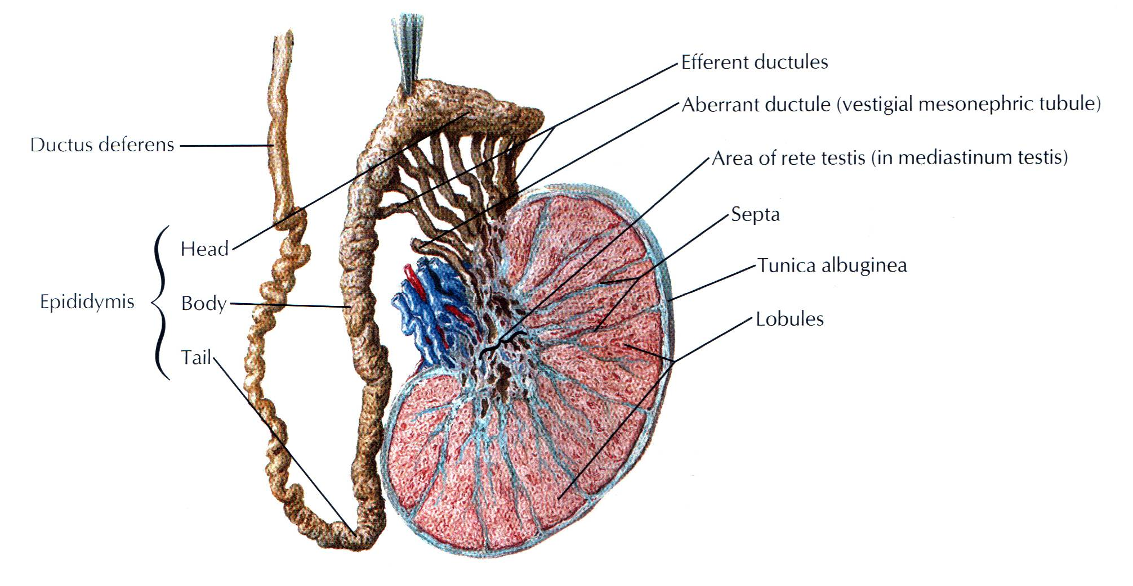

**Figure 2: Frontal section through the testis (Netter, 1989).**

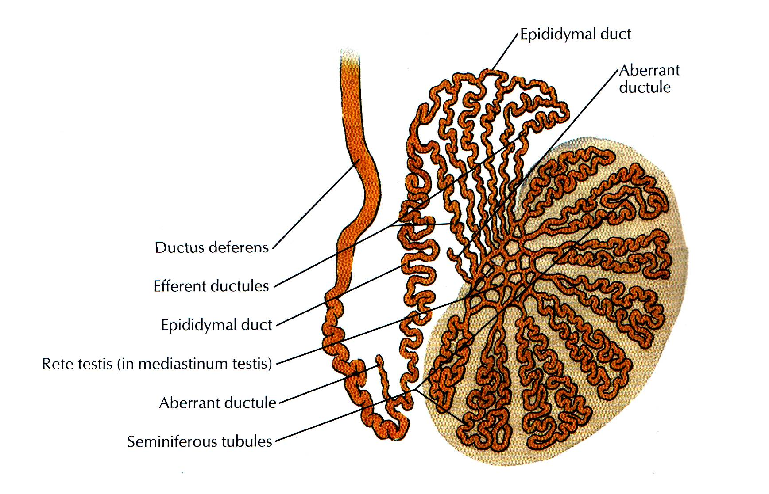

**Figure 3: Schematic diagram of testis (Netter, 1989).**

#### Arterial Supply

The testicular artery is a branch of the abdominal aorta given off at the level of vertebra L2. It descends on the posterior abdominal wall to reach the deep inguinal ring where it enters the spermatic cord. At the posterior border of the testis, it divides into branches. Some small branches enter the posterior border, while larger branches; medial and lateral, pierce the tunica albuginea and run on the surface of the testis to ramify in the tunica vasculosa (Garg, 2016).

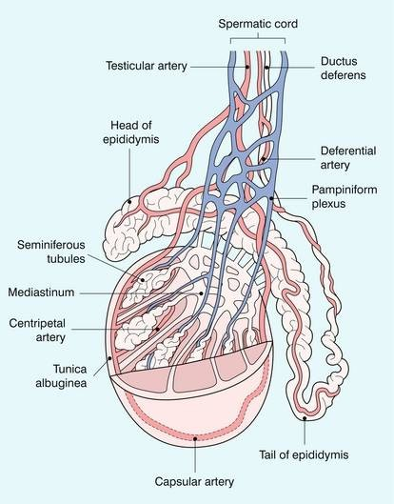

**Figure 4: Schematic diagram of blood supply of testis (Garg, 2016).**

#### Venous Drainage

The veins emerging from the testis form the pampiniformplexus (pampiniform = like a vine). The anterior part of the plexus is arranged around the testicular artery, the middle part around the ductus deferens and its artery, and the posterior part is isolated. The plexus condenses into four veins at the superficial inguinal ring, and into two

veins at the deep inguinal ring. These veins accompany the testicular artery. Ultimately one vein is formed which drains into the inferior vena cava on the right side, and into the left renal vein on the left side.

#### Lymphatic Drainage

The lymphatics from the testis ascend along the testicular vessels and drain into the preaortic and paraaortic groups of lymph nodes at the level of second lumbar vertebra.

#### Nerve Supply

The testis is supplied by sympathetic nerves arising from segment T10 of the spinal cord. They pass through the renal and aortic plexuses. The nerves are both afferent for testicular sensation and efferent to the blood vessels (vasomotor) (Garg, 2016)

#### Histology of Seminiferous Tubule

The seminiferous tubule consists of cells arranged in 4-8 layers in fully functioning testis. These cells are of two types, namely:

1. The spermatogenic cells forming the vast majority.
2. The supporting/sustentacular or cells of Sertoli.

The spermatogenic cells include spermatogonia, primary spermatocytes, secondary spermatocytes, spermatids and spermatozoa. The cells of Sertoli are tall and columnar in shape extending from the basal lamina to the central lumen. They support and protect the developing germ cells and help in maturation of spermatozoa. Spermatogenesis is controlled by follicle stimulating hormone (FSH) of the anterior pituitary gland.

Interstitial cells or cells of Leydig are found as small clusters in between the seminiferous tubules. They secrete testosterone/androgen (I make man). The activity of Leydig cells is controlled by interstitial cell stimulating hormone (ICSH) of the anterior pituitary gland (Garg, 2016)

### EPIDIDYMIS

The epididymis is an organ made up of highly coiled tube that act as reservoir of spermatozoa.

#### Parts:

Its upper end is called the head. The head is enlarged and is connected to the upper pole of the testis by efferent ductules. The middle part is called the body. The lower part is called the tail . The head is made up of highly coiled efferent ductules. The body and tail are made up of a single duct, the duct of the epididymis which is highly coiled on itself. At the lower end of the tail this duct becomes continuous with the ductus deferens.

#### Vessels and Nerves:

The epididymis is supplied by the testicular artery through a branch which anastomoses with and reinforces the tiny artery to the ductus deferens. The venous and lymphatic drainage are similar to those of the testis. Like the testis the epididymis is supplied by sympathetic nerves through the testicular plexus, the fibres of which are derived from segments T11 to LI of the spinal cord.

The tubules of epididymis are lined by pseudo-stratified columnar epithelium with stereocilia. The tubules are surrounded by connective tissue.

### DEVELOPMENT OF TESTIS

Testis: It is comprised of spermatogenic cells, cells of Sertoli and Leydig's cells.

Spermatogenic series of cells are derived from endoderm of dorsocaudal part of yolk sac, i.e. endoderm.

Cells of Sertoli are derived from epithelial cells, i.e. coelomic epithelium.

Leydig’s cells: Mesoderm. There is thick tunica albuginea in the testis and the medulla portion of developing gland predominates (Garg, 2016)

### DESCENT OF THE TESTIS

The testis develop in relation to the developing mesonephros, at the level of segments T10 to T12. Subsequently, they descend to reach the scrotum. Each testis begins to descend during the second month of intrauterine life. It reaches the iliac fossa by the 3rd month, rests at the deep inguinal ring from the 4th to the 6th month, traverses the inguinal canal during the 7th month, reaches the superficial inguinal ring by the 8th month and the bottom of the scrotum by the 9th month. An extension of peritoneal cavity called the processus vaginalis precedes the descent of testis into the scrotum, into which the testis invaginates. The processus vaginalis closes above the testis. Descent does not occur after one year of age.

The causes of descent are not well known. The following factors may help in the process.

1. Hormones including the male sex hormone produced by the testis, and maternal gonadotropins.
2. Differential growth of the body wall.
3. Formation of the gubernaculum: This is a band of loose tissue extending from the lower pole of the testis to the scrotum. It was earlier thought that contraction of this tissue was responsible for descent of the testis, but it is now known that this tissue is not contractile.
4. Intra-abdominal temperature and intra abdominal pressure may have something to do with descent of the testis (Garg, 2016)
5. Mesonephric tubules form functional rete testis and vestigeal paradidymis and aberrant ductules (Garg, 2016)

### BASIC PRINCIPLE OF ULTRASONOGRAPHY

Ultrasound is sound with a frequency greater than 20,000 cycles/sec (Hertz, Hz). Medical sonography employs frequencies between 1 and 20 megahertz (MHz). These high frequencies are produced by subjecting a special ceramic material, a piezoelectric crystal, to a short-voltage spike. A group of synthetic piezoelectric materials called “ceramic ferroelectrics” have replaced the piezoelectric crystal materials that were used earlier. Although PZT is currently the most widely used

material, research suggests that certain plastic polymers may soon replace these synthetic ceramics in the construction of ultrasound transducers. The electric field created by the voltage spike realigns crystalline elements (dipoles) in the ceramic, thereby suddenly changing the crystal's thickness. This sudden change in thickness starts a series of vibrations that products waves.

The piezoelectric crystal is housed in the front of a transducer, a plastic box that protects the crystal from mechanical trauma and provides sonic and electrical insulation. Electrodes are plated onto the surface of the crystal, and the outside elec- trode is grounded to protect the patient from electrical shock. A backing block dampens vibrations between voltage spikes, so the transducer can be used to generate multiple short pulses of sound. If a clinical situation dictates a different frequency, another transducer must be selected, one designed with the appropriate frequency. Piezoelectric crystals can be damaged by heat. Above a critical temperature, called the "Curie temperature," a crystal loses its piezoelectric properties and becomes a worthless piece of ceramic. The Q factor is a measure of the purity of tone (narrowness of frequency range). The ring down-time is the time that it takes a trans- ducer to stop vibrating.

An ultrasonic beam is a series of longitudinal waves that transmit energy. These waves travel through average body tissue at a velocity of 1540 m/sec. Their velocity is independent of frequency. The velocity of sound depends on the density and com- pressibility of the conducting medium, and is equal to the frequency multiplied by the wavelength. As a sound beam passes through the body, the beam is attenuated, or reduced in intensity, by a combination of diffusion, reflection, refraction, and ab- sorption. The sonic beam is fairly coherent with parallel sides in the near, or Fresnel, zone. Beyond a certain critical distance, the transition point, the beam reaches the far, or Fraunhofer, zone and begins to flare out and disperse. The length of the near zone is proportional to the square of the diameter of the transducer and inversely pro- portional to the wavelength of the sound. The beam is rapidly attenuated by dispersion in the far zone. Reflection occurs at tissue interfaces. The incident and reflected angles are equal. The amount of reflection depends on the difference in the acoustic impedance of the two surfaces and on the angle of incidence of the beam. Acoustic

impedance is the product of the density and velocity of sound in the conducting medium. Reflection is greatest with a large difference between the acoustic im- pedance of the two media and with a small incident angle. Reflection is least, and transmission greatest, at an incident angle of 90°.

When the velocity of sound changes as it passes from one medium to another, the frequency remains constant but the wavelength changes. If the wave front strikes the second medium at an angle, the sound is refracted, or bent. The degree of refraction depends on the angle of incidence and on the difference in the velocity of sound in the two media. Absorption, which is the conversion of sound into heat, depends on the frequency of the sound and on both the viscosity and relaxation time of the conducting medium. Absorption in tissue is proportional to frequency; that is, increasing from 1 to 2 MHz doubles absorption and halves the penetrating power of the beam. Therefore, high-frequency sound cannot be used to examine thick body parts.

A longitudinal wave is propagated by multiple particles (molecules) oscillating in the direction of propagation to produce bands of compression and rarefaction in the conducting medium. When these bands are back-scattered to the piezoelec-tric crystal as echoes they change the crystal’s thickness, which produces an electrical signal. This signal forms the basis of the ultrasonicc image. The sound is transmitted in short bursts, or pulses, usually 1000/sec. The pulses are short, about 0.000001 sec in duration. Between pulses the transducer acts as a receiver, recording returning echoes. The time delay between the initiation of a pulse and the return of an echo is converted into depth in all imaging modes. The images can be displayed in several modes. Multiple controls are provided to augment weaker echoes. The most important control is the time gain compensator, which logarithmically enhances echoes from selected depths after an adjustable delay.

Depth resolution, the ability to separate two objects in tandem, depends on the spatial pulse length, which is the number of waves in a pulse multiplied by the wave-length. Depth resolution is best with transducers that have a short spatial pulse length, lateral resolution, the ability to separate two adjacent objects, "depends on the width of the

sonic beam. The beam can be narrowed with an acoustic lens, which bends the sound toward a focal point.

The Doppler effect is a change in the perceived frequency of a sound emitted by a moving source. Doppler devices are used to detect motion. They accomplish this by transmitting a sound beam and recording and demodulating returning echoes. The difference between the two frequencies usually falls in the audible range for most physiologic motions. After amplification the difference becomes an audio signal. Continuous wave Doppler instruments can provide velocity information, but lack any form of depth resolution. Pulsed Doppler instruments provide both depth and velocity information simultaneously. A pulsed Doppler instrument is usually combined with some other form of ultrasound imaging system in a "piggybacked" system. Spectral analysis of a Doppler signal, by allowing evaluation of the spectrum of frequencies making up a Doppler signal, allow evaluation of the nature of blood flow in normal and stenotic blood vessels.

Real-time imaging systems produce image frames fast enough to allow motion to be followed. A compromise between line density per frame and frame rate is required. Frame rate are usually at least 6 frames per second. The real-time image may be generated by a mechanical scanner or by an electronic array arrangement. Mechanical scanners generate a sector format image with either an oscillating transducer or a rotating wheel transducer. Electronic array real-time scanners may use a linear array transducer, which produces a rectangular scan format, or a steered array transducer, which produces a sector format image. Focusing the electronic array ultrasound beam requires both a concave plastic-lens and electronic focusing. Satisfactory beam geometry requires that the individual elements in a linear array transducer be pulsed in groups, commonly four elements at a time, with each group producing one line in the resulting image. With a steered array transducer, all elements of the transducer are pulsed to form each line of the image (Curry et al 1990).

### DOPPLER SONOGRAPHY

Conventional B-mode ultrasound imaging uses pulse-echo transmission, detection, and display techniques. Brief pulses of ultrasound energy emitted by the transducer are reflected from acoustic interfaces within the body. Precise timing allows determination of the depth from which the echo originates. When pulsed wave ultrasound is reflected from an interface, the backscattered (reflected) signal contains amplitude, phase, and frequency information. This information permits inference of the position, nature, and motion of the interface reflecting the pulse. B-mode ultrasound imaging uses only the amplitude information in the backscattered signal to generate the image, with differences in the strength of reflectors displayed in the image in varying shades of gray. Rapidly moving targets, such as red cells in the bloodstream, produce echoes of low amplitude that are not usually displayed, resulting in a relatively anechoic pattern within the lumens of large vessels (Rumack et al 2011).

Although gray-scale display relies on the amplitude of the backscattered ultrasound signal, additional information is present in the returning echoes that can be used to evaluate the motion of moving targets. When high-frequency sound impinges on a stationary interface, the reflected ultrasound has essentially the same frequency or wavelength as the transmitted sound*.* If the reflecting interface is moving with respect to the sound beam emitted from the transducer, however, there is a change in the frequency of the sound scattered by the moving object*.* This change in frequency is directly proportional to the velocity of the reflecting interface relative to the transducer and is a result of the Doppler effect. The relationship of the returning ultrasound frequency to the velocity of the reflector is described by the Doppler equation, as follows:

##### Δ F=(FR-FT)= 2.FT .V/C

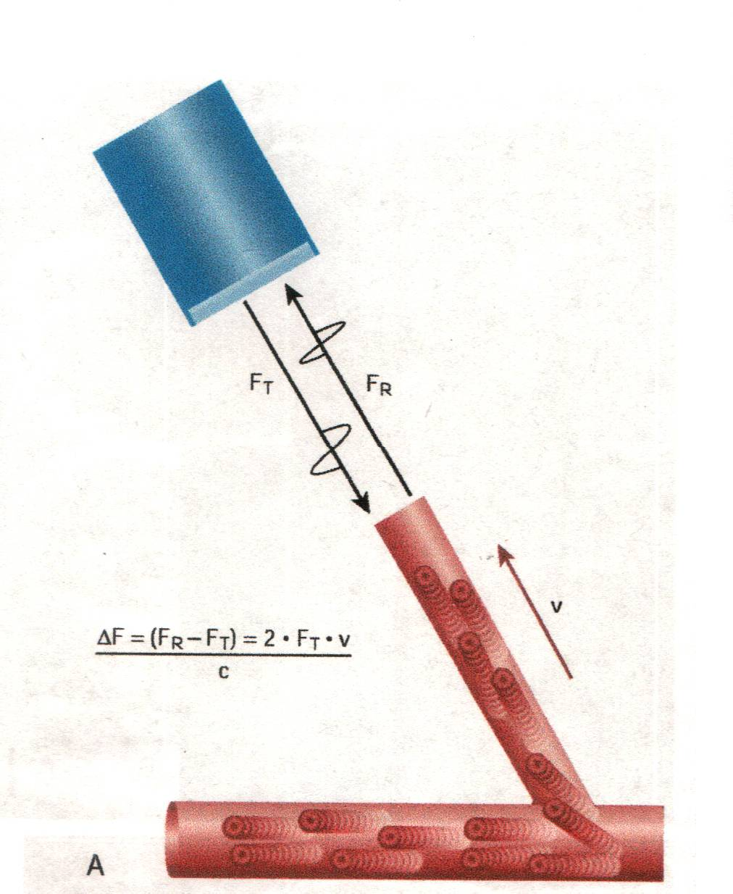

**Figure: Doppler Effect** (Rumack et al 2011).

The Doppler frequency shift is ΔF; FR is the frequency of sound reflected from the moving target; FT is the frequency of sound emitted from the transducer; *V* is the velocity of the target toward the transducer; and *C* is the velocity of sound in the medium. The Doppler frequency shift (ΔF), as just described, applies only if the target is moving directly toward or away from the transducer*.* In most clinical settings the direction of the ultrasound beam is seldom directly toward or away from the direction of flow, and the ultrasound beam usually approaches the moving target at an angle designated as the Doppler angle. In this case, ΔF is reduced in proportion to the cosine of this angle, as follows:

Δ F=(FR-FT)= 2.FT .V. cosθ/C

Where θ is the angle between the axis of flow and the incident ultrasound beam. If the Doppler angle can be measured, estimation of flow velocity is possible. Accurate estimation of target velocity requires precise measurement of both the Doppler frequency shift and the angle of insonation to the direction of target movement. As the Doppler angle (θ) approaches 90 degrees, the cosine of θ approaches 0. At an angle of 90 degrees, there is no relative movement of the target toward or away from the transducer, and no Doppler frequency shift is detected. Because the cosine of the

Doppler angle changes rapidly for angles more than 60 degrees, accurate angle correction requires that Doppler measurements be made at angles of less than 60 degrees. Above 60 degrees, relatively small changes in the Doppler angle are associated with large changes in cosθ, and therefore a small error in estimation of the Doppler angle may result in a large error in the estimation of velocity. These considerations are important in using both duplex and color Doppler instruments. Optimal imaging of the vessel wall is obtained when the axis of the transducer is perpendicular to the wall, whereas maximal Doppler frequency differences are obtained when the transducer axis and the direction of flow are at a relatively small angle (Rumack et al 2011).

In peripheral vascular applications, it is highly desirable that measured Doppler frequencies be corrected for the Doppler angle to provide velocity measurement. This allows comparison of data from systems using different Doppler frequencies and eliminates error in interpretation of frequency data obtained at different Doppler angles. For abdominal applications, angle-corrected velocity measurements are encouraged, although qualitative assessments of flow are often made using only the Doppler frequency shift data. The interrelation of transducer frequency (FT) and the Doppler angle (θ) to the Doppler frequency shift (ΔF) and target velocity described by the Doppler equation are important in proper clinical use of Doppler equipment (Rumack et al 2011).

#### Doppler Signal Processing and Display

Several options exist for the processing of ΔF, the Doppler frequency shift, to provide useful information regarding the direction and velocity of blood. Doppler frequency shifts encountered clinically are in the audible range. This audible signal may be analyzed by ear and, with training, the operator can identify many flow char- acteristics. More often, the Doppler shift data are displayed in graphic form as a time- varying plot of the frequency spectrum of the returning signal. A fast Fourier transformation is used to perform the frequency analysis. The resulting Doppler frequency spectrum displays the following:

* Variation with time of the Doppler frequencies present in the volume sampled.
* The envelope of the spectrum, representing the maximum frequencies present at any given point in time.
* The width of the spectrum at any point, indicating the range of frequencies present.

The amplitude of the Doppler signal is related to the number of targets moving at a given velocity. In many instruments the amplitude of each frequency component is displayed in gray scale as part of the spectrum. The presence of a large number of different frequencies at a given point in the cardiac cycle results in spectral broadening.

In color Doppler imaging systems, a representation of the Doppler frequency shift is displayed as a feature of the image itself*.* In addition to the detection of Doppler frequency shift data from each pixel in the image, these systems may also provide range-gated pulsed wave Doppler with spectral analysis for display of Doppler data (Rumack et al 2011).

#### Doppler Instrumentation

In contrast to A-mode, M-mode, and B-mode gray-scale ultrasonography, which display the information from tissue interfaces, Doppler ultrasound instruments are optimized to display flow information. The simplest Doppler devices use continuous wave rather than pulsed wave ultrasound, using two transducers that transmit and receive ultrasound continuously (continuous wave or CW Doppler). The transmit and receive beams overlap in a sensitive volume at some distance from the transducer face*.* Although direction of flow can be determined with CW Doppler, these devices do not allow discrimination of motion coming from various depths, and the source of the signal being detected is difficult, if not impossible, to ascertain with certainty. Inexpensive and portable, CW Doppler instruments are used primarily at the bedside or intraoperatively to confirm the presence of flow in superficial vessels.

Because of the limitations of CW systems, most applications use range-gated, pulsed wave Doppler. Rather than a continuous wave of ultrasound emission, pulsed wave Doppler devices emit brief pulses of ultrasound energy (Fig. 1-34, *B).* Using pulses of

sound permits use of the time interval between the transmission of a pulse and the return of the echo as a means of determining the depth from which the Doppler shift arises. The principles are similar to the echo-ranging principles used for imaging. In a pulsed wave Doppler system the sensitive volume from which flow data are sampled can be controlled in terms of shape, depth, and position. When pulsed wave Doppler is combined with a 2-D, real-time, B-mode imager in the form a duplex scanner, the position of the Doppler sample can be precisely controlled and monitored.

The most common form of Doppler ultrasound to be used for radiology applications is Color Doppler imaging. In color Doppler imaging systems, frequency shift information determined from Doppler measurements is displayed as a feature of the image itself. Stationary or slowly moving targets provide the basis for the B-mode image. Signal phase provides information about the presence and direction of motion, and changes in echo signal frequency related to the velocity of the target. Backscattered signals from red blood cells are displayed in color as a function of their motion toward or away from the transducer, and the degree of the saturation of the color is used to indicate the relative frequency shift produced by the moving red cells.

#### Color Doppler Flow Imaging (CDFI)

Color Doppler Flow Imaging (CDFI) expands conventional duplex sonography by providing additional capabilities. The use of color saturation to display variations in Doppler shift frequency allows an estimation of relative velocity from the image alone, provided that variations in the Doppler angle are noted. The display of flow throughout the image field allows the position and orientation of the vessel of interest to he observed at all times. The display of spatial information with respect to velocity is ideal for display of small, localized areas of turbulence within a vessel, which provide clues to stenosis or irregularity of the vessel wall caused by atheroma, trauma, or other disease. Flow within the vessel is observed at all points, and stenotic jets and focal areas of turbulence are displayed that might he overlooked widi duplex instrumentation. The contrast of flow within the vessel lumen permits visualization of small vessels that are invisible when using conventional imagers and enhances the visibility of wall irregularity. CDFI aids in determination of the direction of flow and measurement of the Doppler angle (Rumack et al 2011).

# METHODOLOGY

**Study design:**

This was a Cross sectional study.

**Place of study:**

This study was carried out in the Department of Radiology and Imaging, Bangabandhu Sheikh Mujib Medical University, Dhaka.

**Study population:**

This study was carried out on 61 patients with testicular problem referred to the Department of Radiology and Imaging from out patients department.

**Period of study:**

July 2015 to June 2017.

**Sampling method:**

Purposive sampling.

**Sample Size (n):**

We hypothesized that sensitivity of CDUS in the evaluation of testicular lesion was 94% or greater. The sample size was calculated for a power level of 80% (where, Z=0.84), an  error of 0.05 (95% confidence level, where Z=1.96, two tail)

(Hoque, 2009, page 225). From the literature it is known that CDUS is 80% accurate for the diagnosis of testicular lesion.

Sample size was determined by power analysis for a single proportion. Formula for sample size determination for single proportion

n= (*P*  *P* )2

[*Zβ P*(1  *P*)  *Zα P* (1 *P* )]2

0 0

0

n= sample size

P= Proportion under alternative hypothesis (HA) that is proposed to be

detected

P0= Proportion under null hypothesis (H0)

Here,

n= Sample size Z= 0.84

Z= 1.96

P= 97.5%=0. 975

P0= 87.5%=0.875

*n*  (0.975  0.875)2

[0.84 0.975(1  0.975)  1.96 0.875(1  0.875)]2

= 60.7

= 61 (estimated sample size) Therefore target sample was 61.

**Selection criteria:**

**Inclusion criteria**

1. Patients with testicular swelling.
2. Patients with pain and tenderness in the testis
3. Age 18 to 65 years old.

**Exclusion criteria**

1. Inguinoscrotal hernia.
2. Dropped out cases.

**Measures of outcome variable:**

* 1. Demographic and clinical variables: Age

Marital status Testicular pain Testicular swelling Fever

Temperature H/O Trauma

* 1. Sonographic variable: Type of testicular lesion Echogenicity of the lesion Vascularity of the lesion

PSV (Peak systolic velocity) of testicular artery RI (Resistivity Index) of testicular artery

**Data collection technique:**

This cross sectional study was conducted in the Radiology and Imaging department of Bangabandhu Sheikh Mujib Medical University, Dhaka over a span of 12 months from July 2015 to June 2017. The study was approved by the ethical committee of the hospital and a written informed consent was taken from each patient. A total of 61 patients in the age range of 18 to 65 years old, with testicular pathologies were included in the study. After adequate history taking and physical examination, CDUS was performed. The patients were scanned with the linear Color Doppler multi- frequency transducer using **PHILIPS iu22** ultrasound machine and sagittal and transverse images were obtained. Additional views were also obtained in coronal and oblique planes. Reliability of CDUS was determined by comparing it with the final diagnosis, which was based on clinical outcome (ie, positive response to medical treatment), operative findings, fine needle aspiration cytology (FNAC), and histopathological examination results.

**Research instruments:**

A pre-tested questionnaire.

###### Statistical analysis:

The statistical analysis was carried out using the Statistical Package for Social Sciences version 20.0 for Windows (SPSS Inc., Chicago, Illinois, USA). Qualitative variables of this study have been expressed as percentage. Quantitative variables are expressed as mean±standard deviation. For the reliability of study outcome kappa value of the CDUS in the evaluation of testicular lesions was calculated.

**Ethical consideration:**

Prior to the commencement of this study, the research protocol was approved by the thesis committee (Local Ethical Committee). The aims and objective of the study along with its procedure, alternative diagnostic methods, risk and benefits were explained to the patients in easily understandable local language and then informed consent was taken from each patient. It was assured that all records would be kept confidential and the procedure would be helpful for both the physician and patients in making rational approach regarding management of the case.

# RESULTS AND OBSERVATIONS

###### Table I: Particular of the patients (n=51)

|  |  |  |
| --- | --- | --- |
| **Particular of the patients** | **Number of patients** | **Percentage** |
| **Age (in years)**  ≤30 | 35 | 68.6 |
| 31-40 | 9 | 17.6 |
| 41-50 | 1 | 2.0 |
| >50 | 6 | 11.8 |
| Mean±SD | 26.0±14.9 |  |
| Range (min, max) | 18, 65 |  |
| **Marital status**  Married | 25 | 49.0 |
| Unmarried | 26 | 51.0 |

Table I shows particular of the patients; it was observed that more than two third (68.6%) patients belonged to age ≤30 years. The mean age was found 26.0±14.9 years with range from 18 to 65 years. More than half (51.0%) patients were unmarried and 25(49.0%) patients were married.

**Percentage**

###### Figure 1: Bar diagram shows age distribution of the study patients



80

70

60

50

40

30

20

10

0

68.6

17.6

11.8

2.0

≤30 31-40 41-50 >50

**Age (in years)**

|  |  |
| --- | --- |
| **Marital status** |  |
| Married  Unmarried |
| 49.0%  51.0% | |

**Figure 2: Pie chart shows marital status of the study patients**

###### Table II: Distribution of the study patients by clinical presentation (n=51) Clinical presentation Number of patients Percentage Pain 41 80.4

**Percentage**

Scrotal swelling 34 66.7

Fever 15 29.4

H/O Trauma 8 15.7

* Note- Multiple responses were observed

Table II shows clinical presentation of the study patients, it was observed that more than three fourth (80.4%) patients had pain, 34(66.7%) patients had scrotal swelling, 15(29.4%) had fever and 8(15.7%) had H/O trauma.

###### Figure 3: Bar diagram shows clinical presentation of the study patients

90

80

70

60

50

40

30

20

10

0

80.4

66.7

29.4

15.7

Pain

Scrotal swelling

Fever

H/O Trauma

**Clinical presentation**

**Table III: Distribution of the study patients by physical examination (n=51)**

|  |  |  |
| --- | --- | --- |
| **Physical examination** | **Number of patients** | **Percentage** |
| **Pulse**  Normal | 20 | 39.2 |
| Raised | 31 | 60.8 |
| **Temperature** |  |  |
| Normal | 41 | 80.4 |
| Raised | 10 | 19.6 |
| **Scrotal tenderness** |  |  |
| Yes | 31 | 60.8 |
| No | 20 | 38.2 |
| **Scrotal swelling**  Yes | 35 | 62.6 |
| No | 16 | 27.4 |

Table III shows physical examination of the study patients, it was observed that more than two third (60.8%) patients had raised pulse, 10(19.6%) had temperature raised. 31(60.8%) patients had scrotal tenderness and 35(62.6%) patients had scrotal swelling.

###### Table IV: Distribution of the study patients by gray scale of the lesion (n=51)

|  |  |  |
| --- | --- | --- |
| **Gray scale of the lesion** | **Number of patients** | **Percentage** |
| **Type of the lesion**  Diffuse | 39 | 76.5 |
| Focal | 12 | 23.5 |
| **Echogenecity of the lesion** |  |  |
| Hypoechoic | 33 | 64.7 |
| Mixed echogenic | 13 | 25.5 |
| Hyperechoic | 5 | 9.8 |

Table IV shows study patients by gray scale of the lesion, it was observed that more than three fourth (76.5%) of testicular lesions were diffuse and 12(23.5%) were focal in type of the lesion. Almost two third (64.7%) of testicular lesions were found hypoechoic, 13(25.5%) patients were found mixed echogenic and 5(9.8%) patients had hyperechoic in echogenecity.

###### Table V: Distribution of the study patients by CDUS finding of testicular lesion (n=51)

|  |  |  |
| --- | --- | --- |
| **CDUS finding of testicular lesion** | **Number of patients** | **Percentage** |
| **Vascularity of the lesion** |  |  |
| Normal blood flow | 5 | 9.8 |
| Increased blood flow | 36 | 70.6 |
| Decreased blood flow | 6 | 11.8 |
| Absent blood flow | 4 | 7.8 |
| **PSV (Peak systolic velocity)** |  |  |
| Normal | 11 | 21.6 |
| Increased | 28 | 54.9 |
| Decreased | 8 | 15.7 |
| Not performed | 4 | 7.8 |
| **RI (Resistivity index)**  Normal | 11 | 21.6 |
| Increased | 5 | 9.8 |
| Decreased | 31 | 60.8 |
| Not performed | 4 | 7.8 |

Table V shows study patients by CDUS finding of testicular lesion, it was observed that almost three fourth (70.6%) of testicular lesions had increased vascularity of the lesion, 28(54.9%) had increased PSV (Peak systolic velocity). Almost two third (60.8%) patients had found decreased RI (Resistivity index).

**Percentage**

###### Table VI: Distribution of the study patients by Color Doppler Ultrasound (CDUS) diagnosis of testicular lesions (n=51)

**CDUS diagnosis of testicular lesions Number of patients Percentage**

Orchitis 34 66.7

Seminoma 5 9.8

Abscess 4 7.8

Torsion 5 9.8

Haematoma 3 5.9

Table VI shows Color Doppler Ultrasound diagnosis of the study patients. It was observed that 34(66.7%) patients were diagnosed as orchitis, 5(9.8%) as seminoma and 5(9.8%) as torsion. Other result depicted in the above table.

###### Figure 4: Bar diagram shows Color Doppler Ultrasound diagnosis of the study patients

70

66.7

60

50

40

30

20

9.8

7.8

9.8

5.9

10

0

Orchitis Seminoma Abscess

Torsion Haematom

**Color Doppler ultrasound diagnosis**

**Table VII: Distribution of the study patients by intervention (n=51)**

|  |  |  |
| --- | --- | --- |
| **Intervention** | **Number of patients** | **Percentage** |
| Conservative | 25 | 49.0 |
| Surgery | 5 | 9.8 |
| FNAC | 21 | 41.2 |

Table VII shows intervention of the study patients, it was observed that almost half (49.0%) patients were managed conservatively and Final Clinical Diagnosis were made observing the response to medical treatment, 21(41.2%) patients were performed FNAC, 5(9.8%) patients under went surgery and finally diagnosed accordingly.

|  |  |
| --- | --- |
| 21(41.2%) | Conservative  Surgery FNAC |
| 25(49.0%)  5(9.8%)  **Intervention** | |

###### Figure 5: Bar diagram shows intervention of the study patients

**Percentage**

**Table VIII: Distribution of the study patients by Final Clinical Diagnosis of testicular lesions on the basis of final outcome, FNAC and surgery. (n=51)**

|  |  |  |
| --- | --- | --- |
| **Final Clinical Diagnosisof testicular**  **lesions** | **Number of patients** | **Percentage** |
| Orchitis | 31 | 60.8 |
| Seminoma | 7 | 13.7 |
| Abscess | 6 | 11.8 |
| Torsion | 4 | 7.8 |
| Haematoma | 3 | 5.9 |

Table VIII shows Final Clinical Diagnosis of testicular lesions of the study patients.It was observed that almost two third (60.8%) patients had orchitis, 7(13.7%) patients had seminoma, 6(11.7%) patients had abscess. Other result depicted in the above table.

**Figure 6: Bar diagram shows Final Clinical Diagnosis of the study patients**

70

60.8

60

50

40

30

20

10

0

13.7

11.8

7.8

5.9

Orchitis Seminoma Abscess Torsion Haematoma

**Final Clinical Diagnosis**

**Table IX: Agreement (Reliability) of Color Doppler ultrasound diagnosis with Final Clinical Diagnosis of testicular lesions (n=51)**

**CDUS Diagnosis Final Clinical Diagnosis(on the basis of final outcome,FNAC**

**and surgery)**

**Orchitis (n=31)**

**Seminoma (n=7)**

**Abscess (n=6)**

**Torsion (n=4)**

**Haematoma (n=3)**

|  |  |  |  |  |  |  |  |  |  |  |
| --- | --- | --- | --- | --- | --- | --- | --- | --- | --- | --- |
|  | **n** | **%** | **n** | **%** | **n** | **%** | **n** | **%** | **n** | **%** |
| Orchitis (n=34) | 31 | 92.8 | 3 | 7.2 | 0 | 0.0 | 0 | 0.0 | 0 | 0.0 |
| Seminoma (n=5) | 0 | 0.0 | 4 | 80.0 | 0 | 0.0 | 0 | 0.0 | 1 | 20.0 |
| Abscess (n=4) | 0 | 0.0 | 0 | 0.0 | 4 | 100.0 | 0 | 0.0 | 0 | 0.0 |
| Torsion (n=5) | 0 | 0.0 | 0 | 0.0 | 0 | 0.0 | 4 | 80.0 | 1 | 20.0 |
| Haematoma (n=3) | 0 | 0.0 | 0 | 0.0 | 2 | 66.7 | 0 | 0.0 | 1 | 33.3 |

**Kappa value 0.797**

**p value 0.001s**

A total 34 patient had orchitis in CDUS diagnosis, among them 31(92.8%) patients had orchitis in final clinical diagnosis. 5 patients had seminoma in CDUS diagnosis, among them 4(80.0%) patients had seminoma in final clinical diagnosis. 4 patients had abscess in CDUS diagnosis, among them 4(100.0%) patients had abscess in final clinical diagnosis. 5 patients had torsion in CDUS diagnosis, among them 4(80.0%) patients had torsion in final clinical diagnosis. 3 patients had haematoma in CDUS diagnosis, among them 1(33.3%) patients had haematoma in final clinical diagnosis. The results of the two modalities (CDUS and final clinical diagnosis findings) analysis found Kappa value = 0.797 with p value <0.05. This measure of agreement is statistically significant with substantial agreement between CDUS & final clinical diagnosisin the evaluation of testicular lesions.

s=significant

Measures of agreement Kappa Value 0.797, p value 0.001s Kappa value is near to 1 that indicates good agreement.

Kappa Value 79.7=Substantial agreement.

###### Kappa Interpretation

< 0 Poor agreement

0.0 – 0.20 Slight agreement

0.21 – 0.40 Fair agreement

0.41 – 0.60 Moderate agreement

0.61 – 0.80 Substantial agreement

0.81 – 1.00 Almost perfect agreement

# DISCUSSION

This cross sectional study was carried out with an aim to determine the value of Color Doppler ultrasonography (CDUS) as a routine investigational method for the diagnosis of testicular lesions.

A total of 51 consecutive patients were attended in Department of Radiology and Imaging during July 2015 - June 2017. Clinically diagnosed testicular lesion and age 18 to 65 years old were enrolled in this study. Inguinoscrotal hernia and undescended testis were excluded from the study. The present study findings were discussed and compared with previously published relevant studies.

In this present study, it was observed that more than two third (68.6%) patients belonged to age 21-30 years. The mean age was found 26.0±14.9 years with range from 17 to 65 years. Rizvi et al. (2011) observed 122 patients in the age range of 13 to 70 years old, Woodward et al. (2002) found the most common malignancy in the 15– 34-year-old age group, which are comparable with the current study. Similar age ranged also observed by Varsamidis et al. (2001) where the authors observed aged range varied from 18–66 years. On the other hand Lung et al. (2012) and Bilagi et al. (2007) found the median age of the patients was 49 years with ranged from 18– 81years and 37 years with ranged from 16-82 years respectively. Similarly higher mean age also observed by Woodward et al. (2002), which all are higher with the current study. The higher mean age and age range may be due to geographical variations, racial, ethnic differences and genetic causes may have significant influence on testicular lesions. In this current series, it was observed that more than half (51.0%) patients were unmarried and 49.0% were married.

In this present study, it was observed that more than three fourth (80.4%) patients with testicular lesions had pain. Lung et al. (2012) found in their study that all of the patients presented with scrotal pain. Pain is a much less common presenting symptom, reported by approximately 10.0% of patients (Ulbright et al. 1999). Similar findings also observed by Varsamidis et al. (2001) and Atkinson et al. (1992). In this current study, it was observed that 29.4% patients with testicular lesions had fever.Although

the most common presenting complain is painless testicular enlargement, systemic symptoms such as weight loss, anorexia, fever and weakness have been reported as the initial complain in 25% of patients (Mostofi et al.1973), which is comparable with the current study. In this current series, it was observed that 15.7% and 66.7% patients had H/O trauma and scrotal swelling respectively.The causes of scrotal swelling can be classified as acute and non-acute. Acute causes include torsion, trauma, abscess, and orchitis. Non acute causes include hydrocele, scrotal hernia, lymphocele and others. Scrotal lesions can also be classified as testicular and extratesticular. The common testicular lesions are torsion, trauma, neoplasms, and inflammatory conditions (Rizvi et al. 2011).

During physical examination, it was observed in this present study that almost two third 60.8% patients had raised pulse, 19.6% raised temperature, 60.8% scrotal tenderness and 62.6% patients had scrotal swelling.

In this current study, it was observed that more than three fourth (76.5%) patients had diffuse and 23.5% had focal type of testicular lesion. Rizvi et al. (2011) study showed diffuse involvement in 63.4% of their study patients, which is comparable with the current study. In this present study, it was observed that almost two third (64.7%) of the patients had hypoechoic lesion and 25.5% had mixed echogenic lesion. Lung et al. (2012) found lesions were isoechoic 6.25%, hypoechoic 25.0%, of mixed echogenicity 68.75%, which is comparable with the current study. Rizvi et al. (2011) observed in all the patients, the epididymis was enlarged, hypoechoic, and hyperemic. In 5 patients, in addition to the epididymis, the testis was also hypoechoic and hyperemic. Two patients were diagnosed as cases of testicular torsion. Both patients showed mild enlargement, hypoechoic echotexture, and markedly decreased vascularity.

In this present study, it was observed that almost three fourth (70.6%) patients had increased vascularity of the lesion and 7.8% showed absent blood flow. Increased vascularity was revealed in all the subjects observed by Rizvi et al. (2011) and diagnoses of testicular mass and orchitis were made in 16 and 6 patients, respectively. Color Doppler ultrasound flow was not clearly depicted in 13 lesions but was present in three lesions, with contrast-enhanced ultrasound concordant with color Doppler

ultrasound, showing unequivocal absence of vascularity and increased flow, respectively (Lung et al. 2012).In this current study, it was observed that more than half (54.9%) patients had increased PSV (Peak syatolic velocity). Almost two third (60.8%) patients had decreased RI (Resistivity index) and 21.6% had normal RI. Elevated peak systolic velocity has been noted by Horstman et al. (1992) in testicular tumors (mean 19.8 cm/s) and Brown et al. (1995) observed statistically significantly lower (p<0.05) peak velocity in healthy subjects than that found in patients with orchitis. In Varsamidis et al. (2001) study, the RI presented no significant variation at all. We also noted that elevated velocity values observed both in patients with testicular tumor and orchitis did not allow any diagnostic differentiation based on Doppler criteria at the initial examination. On the contrary, follow-up examination on completion of 1-week proper antibiotic treatment showed normalization of velocity values in patients with orchitis while persistent high velocities were seen in patients with tumor. This suggests that follow-up examination is important in patients with acute scrotal pain submitted to antibiotic treatment since it may permit a reliable differentiation between orchitis and tumor.

In this present study, it was observed that 66.7% patients had orchitis, 9.8% patients had seminoma, 9.8% torsion, 7.8% abscess and 5.9% haematoma in CDUS. With the help of CDUS, the diagnoses of epididymitis and epididymo-orchitis were made in 46 out of 52 patients who presented with clinical suspicion observed by Rizvi et al. (2011). Four patients were clinically diagnosed as cases of testicular torsion. Color Doppler ultrasonography showed absent intratesticular blood flow confirming the diagnosis. Surgery was done, which supported the diagnosis. Varsamidis et al. (2001) mentioned in their study that tumor cell types included 4 seminomas, 6 mixed germ cell tumors and 1 teratoma. In 7 patients the Final Clinical Diagnosis of testicular inflammation (diffuse or focal orchitis) was based on the complete response to proper antibiotic treatment with resolution of symptoms along with normal US findings in two consecutive follow-up examinations (time interval 5.96±0.89 months, mean

±1SD). Goldenberg and Gilbert (2015) found 20.0% were diagnosed with testicular torsion, 56.0% with torsion of an appendage, 8.0% with epididymitis, and 11.0% with no definite diagnosis.

In this series, it was observed that almost half (49.0%) of study patients were managed conservatively and Final Clinical Diagnosis were made observing the response to medical treatment, 41.2% patients were performed FNAC, 9.8% patients under went surgery and finally diagnosed accordingly. Rizvi et al.(2011) mentioned that 46 patients were conservatively managed and follow-up CDUS revealed resolution of findings. Subsequently, all 16 subjects with diagnosis of testicular mass were subjected to FNAC. In all confirmed cases of seminoma, orchidectomy was performed and FNAC diagnoses were comparable to final histopathological examination. Varsamidis et al. (2009) observed 3.7% patients testicular contusion was the Final Clinical Diagnosis and in 4.1% patients, testicular torsion was ultimately verified on the basis of typical color Doppler US and surgery. A conservative clinical approach to surgical exploration may lead to under diagnosis of appendage torsion; however, nondiagnosis has no real clinical significance. Accurate diagnosis of appendage torsion is important principally because of its ability to mimic testicular torsion, leading to unnecessary exploratory surgery (Fitzgerald et al. 1992).

Regarding the Final Clinical Diagnosis in this current study, it was observed that almost two third (60.8%) patients had orchitis, 13.7% patients had seminoma, 11.7% patients had abscess, 7.8% torsion and 5.9% had haematoma. Rizvi et al.(2011) observed 14 out of 16 patients turned out to be seminoma while 2 misdiagnosed subjects turned out to be orchitis. 6 out of 22 clinically diagnosed cases of testicular mass were labeled as orchitis on CDUS. However, FNAC results showed one of them to be seminoma. In all confirmed cases of seminoma, orchidectomy was performed and FNAC diagnoses were comparable to final histopathological examination. Goldenberg and Gilbert (2015) reported that a testicular abscess is seen in approximately 5 % of patients with orchitits and usually appears 1–7 weeks after orchitis, often as a result of ineffective treatment.

In this present study total 34 patient had orchitis in CDUS diagnosis, among them 31(92.8%) patients had orchitis in final clinical diagnosis. 5 patients had seminoma in CDUS diagnosis, among them 4(80.0%) patients had seminoma in final clinical diagnosis. 4 patients had abscess in CDUS diagnosis, among them all 4(100.0%) patients had abscess in final clinical diagnosis. 5 patients had torsion in CDUS

diagnosis, among them 4(80.0%) patients had torsion in final clinical diagnosis. 3 patients had haematoma in CDUS diagnosis, among them 1(33.3%) patients had haematoma in final clinical diagnosis. The results of the two modalities (CDUS and Final Clinical Diagnosis findings) analysis found Kappa value = 0.797 with p value

<0.05. This measure of agreement is statistically significant with substantial agreement between CDUS & Final Clinical Diagnosis in the evaluation of testicular lesions.

# SUMMARY

This cross sectional study was carried out in the department of Radiology & Imaging of Bangabandhu Sheikh Mujib Medical University, Dhaka, Bangladesh during July 2015-June 2017 to determine the value of Color Doppler ultrasonography (CDUS) as a routine investigational method for diagnosis of testicular lesions.

For this purpose, a total of 61 patients with testicular problem were included in this study referred to the Department of Radiology and Imaging from out patients department. Color Doppler ultrasonography (CDUS) was done in all these patients. They were followed up upto the Final Clinical Diagnosis of testicular lesions in respective surgery departments for final outcome, Fine needle aspiration cytology (FNAC), histopathological and operative findings correlation. Clinically diagnosed testicular lesion and age 18 to 65 years old were enrolled in this study. Inguinoscrotal hernia and undescended testis were excluded from the study. The following observations and results were obtained in this study.

The mean age was found 26.0±14.9 years with range from 18 to 65 years. More than three fourth (80.4%) patients had pain, H/O scrotal swelling 34(66.7%), fever 15(29.4%) and H/O trauma 8(15.7%). Almost two third (60.8%) patients had raised pulse, 10(19.6%) raised temperature and 31(60.8%) scrotal tenderness.

More than three fourth (56.0%) of tesicular lesions were diffuse. Almost two third (64.7%) of testicular lesions were hypoechoic, 13(25.5%) patients were mixed echogenic in echogenicity of the lesion. Almost three fourth (70.6%) testicular lesions had increased vascularity, 28(54.9%) testicular lesions had increased PSV (Peak systolic velocity), 31(60.8%) testicular lesions had decreased RI (Resistivity index).

Two third (66.7%) patients were diagnosed as orchitis, 5(9.8%) as seminoma and 4(7.8%) as abscess in Color Doppler Ultrasound. Almost half (49.0%) patients were managed conservatively and Final Clinical Diagnosis were made observing the response to medical treatment, 21(41.2%) patients were performed FNAC, 5(9.8%) patients under went surgery and finally diagnosed accordingly.

A total 34 patient had orchitis in CDUS diagnosis, among them 31(92.8%) patients had orchitis in final clinical diagnosis. 5 patients had seminoma in CDUS diagnosis, among them 4(80.0%) patients had seminoma in final clinical diagnosis. 4 patients had abscess in CDUS diagnosis, among them 4(100.0%) patients had abscess in final clinical diagnosis. 5 patients had torsion in CDUS diagnosis, among them 4(80.0%) patients had torsion in final clinical diagnosis. 3 patients had haematoma in CDUS diagnosis, among them 1(33.3%) patients had haematoma in final clinical diagnosis. The results of the two modalities (CDUS and Final Clinical Diagnosis findings) analysis found Kappa value = 0.797 with p value <0.05. This measure of agreement is statistically significant with substantial agreement between CDUS & Final Clinical Diagnosis in the evaluation of testicular lesions.

# CONCLUSION

This study was undertaken to determine the value of Color Doppler Ultrasonography (CDUS) as a routine investigational method for diagnosis of testicular lesions. Color Doppler Ultrasonography has definite value in the diagnosis and evaluation of testicular lesion and can be regarded as a reliable imaging modality. In this study, Final Clinical Diagnosis of testicular lesions (on the basis of final outcome, FNAC and surgery) showed significant similarities with Color Doppler Ultrasonography findings in the diagnosis of testicular lesion and the reliability tests are almost identical as observed by many investigations. It can be concluded that the Color Doppler Ultrasonography imaging is efficient imaging modality in detecting testicular lesions as well as vascularity of the lesions. Hence, it should be worthy to note that Color Doppler Ultrasonography can help the physician and surgeon in the rational approach of patient management and mapping of the testicular lesion pre-operatively.

# LIMITATIONS

1. The study population was selected from one selected hospital in Dhaka city, so that the results of the study may not be reflect the exact picture of the country.
2. The present study was conducted at a short period of time.
3. In this study total estimated sample was 61 but during the study period a total of 10 samples were dropped out. Therefore this was also a limitation of the study.

# RECOMMENDATION

Colour Doppler Ultra Sonography (CDUS) is a sensitive and reliable tool for the evaluation of testicular lesions, which suggest that CDUS can be used as an effective diagnostic tool. As Bangladesh is a densely populated country, multicentric study with larger sample size would be ideal to give significant conclusion reflecting national picture.

# BIBLIOGRAPHY

Agrawal, A.M., Tripathi, P.S., Shankhwar, A. and Naveen, C., 2014. Role of ultrasound with color Doppler in acute scrotum management. *Journal of family medicine and primary care*,*3*(4), p.409-12.

Atchley, JTM & Dewbury, KC 2000, ‘Ultrasound appearances of testicular epidermoid cysts’, *Clin Radiol*, vol. 55, pp. 493–502.

Atkinson Jr, G.O., Patrick, L.E., Ball Jr, T.I., Stephenson, C.A., Broecker, B.H. and Woodard, J.R., 1992. The normal and abnormal scrotum in children: evaluation with color Doppler sonography. *AJR. American journal of roentgenology*, *158*(3), pp.613- 17.

Atkinson, GO, Jr., Patrick, LE, Ball, TI, Jr., Stephenson, CA, Broecker, BH & Woodard, JR 1992, ‘The normal and abnormal scrotum in children: evaluation with Color Doppler sonography’, *AJR Am J Roentgenol,* vol. 158, pp. 613-7.

Becker, D., Bürst, M., Wehler, M., Tauschek, D., Herold, C. and Hahn, E.G., 1997. Differential diagnosis of acute testicular pain using color-coded duplex ultrasonography: difference between testicular torsion and epididymitis.*Deutsche medizinische Wochenschrift (1946)*, *122*(46), pp.1405-09.

Bilagi, P., Sriprasad, S., Clarke, J.L., Sellars, M.E., Muir, G.H. and Sidhu, P.S., 2007. Clinical and ultrasound features of segmental testicular infarction: six-year experience from a single centre. *European radiology*, *17*(11), pp.2810-18.

Browm, J.M., Hammers, L.W., Barton, J.W. et al., 1995. Quantitative Doppler assessment of acute scrotal inflammation. *Radiology*, 197, p.427.

Buckley, J.C. and McAninch, J.W., 2006. Use of ultrasonography for the diagnosis of testicular injuries in blunt scrotal trauma. *The Journal of urology*,*175*(1), pp.175-78.

Cassar, S., Bhatt, S., Paltiel, H.J. and Dogra, V.S., 2008. Role of spectral Doppler sonography in the evaluation of partial testicular torsion. *Journal of Ultrasound in Medicine*, *27*(11), pp.1629-1638.

Cook, JL & Dewbury, K 2000, ‘The changes seen on high-resolution ultrasound in orchitis’, *Clin Radiol*, vol. 55, pp. 13–18.

D’Andrea, A., Coppolino, F., Cesarano, E., Russo, A., Cappabianca, S., Genovese, E.A., Fonio, P. and Macarini, L., 2013. US in the assessment of acute scrotum. *Critical ultrasound journal*, *5*(1), p.S8.

Derouet, H., Braedel, H.U., Brill, G., Hinkeldey, K., Steffens, J. and Ziegler, M., 1993. Nuclear magnetic resonance tomography for improving the differential diagnosis of pathologic changes in the scrotal contents. *Der Urologe. Ausg. A*, *32*(4), pp.327-33.

Dogra, V., Nathan, J. and Bhatt, S., 2004. Sonographic appearance of testicular adrenal rest tissue in congenital adrenal hyperplasia. *Journal of ultrasound in medicine*, *23*(7), pp.979-81.

Dogra, VS, Gottlieb, R, Rubens, DJ & Liao, L 2001, ‘Benign intratesticular cystic lesions: US features’, *Radiographics*, vol. 21, pp. S273–81.

Etai Goldenberg and Bruce R. Gilbert. Scrotal Ultrasound. Springer Science+Business Media New York 2015.

Fernandez-Perez, G.C., Tardáguila, F.M., Velasco, M., Rivas, C., Dos Santos, J., Cambronero, J., Trinidad, C. and San Miguel, P., 2005. Radiologic findings of segmental testicular infarction. *American Journal of Roentgenology*, *184*(5), pp.1587- 93.

Fitzgerald, SW, Erickson, S & DeWire, DM 1992, ‘Color Doppler sonography in the evaluation of the adult acute scrotum’, *J Ultrasound Med,* vol. 11, pp. 543-8.

Gallardo Agromayor E, Pena Gomez E, Lopez Rasines G, et al. 1996.Testicular tumors. Echographic findings. *Arch Esp Uro,* 49, pp.622-26.

Garg 2010, k (ed). Male External Genital Organs. BD Garg 2004’s Human Anatomy, regional and applied. Volume 5th edition 2010. CBSP Publishers and distributors, New Delhi. P.234-240.

Gorman B. The Scrotum. In: Rumack CM, editor. Diagnostic Ultrasound. 4th ed. Vol.

1. USA: Elsevier Mosby; 2011. pp. 864–9.

Guichard, G., El Ammari, J., Del Coro, C., Cellarier, D., Loock, P.Y., Chabannes, E., Bernardini, S., Bittard, H. and Kleinclauss, F., 2008. Accuracy of ultrasonography in diagnosis of testicular rupture after blunt scrotal trauma. *Urology*, *71*(1), pp.52-56.

Hoque, M 2009, ‘abc of research methodology and biostatistics’, 1st edition, Parash Publishers, 155 Dhaka New Marker, Dhaka-1205, p. 225.

Horstman, W.G., Melson, G.L., Middleton, W.D. and Andriole, G.L., 1992. Testicular tumors: findings with color Doppler US. *Radiology*, *185*(3), pp.733-37.

Huang, D.Y. and Sidhu, P.S., 2012. Focal testicular lesions: colour Doppler ultrasound, contrast-enhanced ultrasound and tissue elastography as adjuvants to the diagnosis. *The British journal of radiology,* 85, pp.41-53.

Karmazyn, B., Steinberg, R., Kornreich, L., Freud, E., Grozovski, S., Schwarz, M., Ziv, N. and Livne, P., 2005. Clinical and sonographic criteria of acute scrotum in children: a retrospective study of 172 boys. *Pediatric radiology*, *35*(3), pp.302-10.

Lerner, RM, Mevorach, RA, Hulbert, WC & Rabinowitz, R 1990, ‘Color Doppler US in the evaluation of acute scrotal disease’, *Radiology,* vol. 176, pp. 355-8.

Liang, T., Metcalfe, P., Sevcik, W. and Noga, M., 2013. Retrospective review of diagnosis and treatment in children presenting to the pediatric department with acute scrotum. *American Journal of Roentgenology*, *200*(5), pp.W444-W449.

Lung, P.F., Jaffer, O.S., Sellars, M.E., Sriprasad, S., Kooiman, G.G. and Sidhu, P.S., 2012. Contrast-enhanced ultrasound in the evaluation of focal testicular complications secondary to epididymitis. *American Journal of Roentgenology*, *199*(3), pp.W345- W354.

Lutzker, LG & Zuckier, LS 1990, ‘Testicular scanning and other applications of radionuclide imaging of the genital tract’, *Semin Nucl Med,* vol. 20, pp. 159-88.

Megremis, S., Michalakou, M., Mattheakis, M., Agianniotakis, E. and Sfakianaki, E., 2005. An unusual well-circumscribed intratesticular traumatic haematoma diagnosis and follow-up by sonography. *Journal of ultrasound in medicine*, *24*(4), pp.547-50.

Middleton, WD, Siegel, BA, Melson, GL, Yates, CK & Andriole, GL 1990, ‘Acute scrotal disorders: prospective comparison of Color Doppler US and testicular scintigraphy’, *Radiology,* vol. 177, pp. 177-81.

Mishkin, F.S., 1977. Differential diagnostic features of the radionuclide scrotal image. *American Journal of Roentgenology*, *128*(1), pp.127-29.

Mostofi, F.K. and Price, E.B. 1973. Tumors of the male genital system. In: Atlas of tumor pathology, fasc 8, ser 2. Washington, DC. *Armed Forces Institute of Pathology*, pp.1–310.

Netter, F.H. and Colacino, S., 1989. *Atlas of human anatomy* (Vol. 11). Summit, NJ: Ciba-Geigy.

Patel, K., Sellars, M.E., Clarke, J.L. and Sidhu, P.S., 2012. Features of Testicular Epidermoid Cysts on Contrast◻Enhanced Sonography and Real◻time Tissue Elastography. *Journal of Ultrasound in Medicine*, *31*(1), pp.115-122.

Pavlica, P & Barozzi, L 2001, ‘Imaging of the acute scrotum’, *Eur Radiol,* vol. 11, pp. 220-8.

Price, EB 1969, ‘Epidermoid cysts of the testis: a clinical and pathologic analysis of 69 cases from the testicular tumour registry’, *J Urology*, vol. 102, pp. 708–13.

Purushothaman, H., Sellars, M.E.K., Clarke, J.L. and Sidhu, P.S., 2007. Intratesticular haematoma: differentiation from tumour on clinical history and ultrasound appearances in two cases. *The British journal of radiology*, 80, pp. e184-e87.

Rizvi, S.A.A., Ahmad, I., Siddiqui, M.A., Zaheer, S. and Ahmad, K., 2011. Role of color Doppler ultrasonography in evaluation of scrotal swellings: pattern of disease in 120 patients with review of literature. *Urology journal*, *8*(1), p.60.

Rumack, M.C., 2011. Diagnostic Ultrasound, 4th edn, *Elsevier Mosby, Philadelphia*,

pp. 20-25.

Sanders, LM, Haber, S, Dembner, A & Aquino, A 1994, ‘Significance of reversal of diastolic flow in the acute scrotum’, *J Ultrasound Med*, vol. 13, pp. 137–9.

Sellars, ME & Sidhu, PS 001, ‘Pictorial review: ultrasound appearances of the rete testis’, *Euro J Ultrasound*, vol. 14, pp. 115–20.

Sriprasad, S., Kooiman, G.G., Muir, G.H. and Sidhu, P.S., 2001. Acute segmental testicular infarction: differentiation from tumour using high frequency colour Doppler ultrasound. *The British journal of radiology*, *74*(886), pp.965-67.

Stewart, V.R., Sellars, M.E., Somers, S., Muir, G.H. and Sidhu, P.S., 2004. Splenogonadal Fusion B-Mode and Color Doppler Sonographic Appearances.*Journal of ultrasound in medicine*, *23*(8), pp.1087-90.

Stewart, VR & Sidhu, PS 2007, ‘The testis: the unusual, the rare and the bizarre’, *Clin Radiol*, vol. 62, pp. 289–302.

Suzer, O., Ozcan, H., Küpeli, S. and Gheiler, E.L., 1997. Color Doppler imaging in the diagnosis of the acute scrotum. *European urology*, *32*(4), pp.457-61.

Terai, A., Yoshimura, K., Ichioka, K., Ueda, N., Utsunomiya, N., Kohei, N., Arai, Y. and Watanabe, Y., 2006. Dynamic contrast-enhanced subtraction magnetic resonance imaging in diagnostics of testicular torsion. *Urology*, *67*(6), pp.1278-82.

Ulbright, T.M., Amin, M.B. and Young, R.H. 1999. Tumors of the testis, adnexa, spermatic cord, and scrotum. In: Atlas of tumor pathology, fasc 25, ser 3. Washington, DC. *Armed Forces Institute of Pathology*, pp.1–290.

Varsamidis, K., Varsamidou, E. and Mavropoulos, G., 2001. Doppler ultrasonography in testicular tumors presenting with acute scrotal pain. *Acta Radiologica*, *42*(2), pp.230-33.

Watanabe, Y, Dohke, M & Ohkubo, K 2000, ‘Scrotal disorders: evaluation of testicular enhancement patterns at dynamic contrast-enhanced subtraction MR imaging’, *Radiology,* vol. 217, pp. 219-27.

Woodward, P.J., Sohaey, R., O’Donoghue, M.J. and Green, D.E., 2002. From the Archives of the AFIP: Tumors and Tumorlike Lesions of the Testis: Radiologic- Pathologic Correlation 1. *Radiographics*, *22*(1), pp.189-216.

Yusuf, G.T. and Sidhu, P.S., 2013. A review of ultrasound imaging in scrotal emergencies. *Journal of ultrasound*, *16*(4), pp.171-178.

Zoller, G, Kugler, A & Ringert, RH 2000, ‘False positive testicular perfusion in testicular torsion in power Doppler ultrasound’, *Urologe A,* vol. 39, pp. 251-3.

# APPENDIX-I

**Clearance of certificate of Institutional Review Board (IRB)**

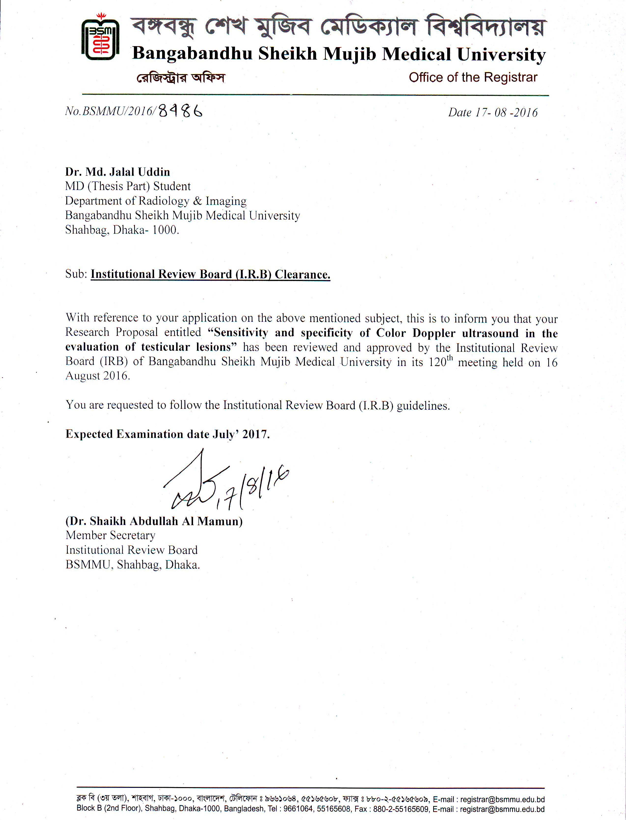

**APPENDIX -II**

## DATA COLLECTION SHEET

#### Title: Sensitivity and specificity of Color Doppler ultrasound in the evaluation of testicular lesions.

Principal Investigator: Dr. Md. Jalal Uddin Particulars of the patient:

1. Sl. no.  Case no. Date :

|  |  |  |
| --- | --- | --- |
|  |  |  |

|  |  |  |
| --- | --- | --- |
|  |  |  |

1. Name: … … … … … … … … … … … … … … … … … … … … …
2. Age: Years

|  |  |  |
| --- | --- | --- |
|  |  |  |

1. Marital status:  1= Married 2= Unmarried

Address : … … … … … … … … … … … … … … … … … … …

1. Occupation: …………………………………………………….

|  |  |  |  |  |
| --- | --- | --- | --- | --- |
| 6. Clinical Presentation | i. Pain |  | 1. Yes | 2. No |
|  |  |  |  |  |
|  | ii. Fever |  | 1. Yes | 2. No |
|  |  |  |  |  |
|  | iii. Scrotal Swelling |  | 1. Yes | 2. No |
|  |  |  |  |  |
|  | iv. H/O Trauma |  | 1. Yes | 2. No |

|  |  |  |  |  |
| --- | --- | --- | --- | --- |
| 7. Physical Examination | i. Pulse |  | 1. Normal | 2. Raised |
|  |  |  |  |  |
|  | ii. Temperature |  | 1. Normal | 2. Raised |
|  |  |  |  |  |
|  | iii.. Scrotal Tendern |  | 1. Yes | 2. No |
|  |  |  |  |  |
|  | iv. Scrotal Swelling |  | 1. . Yes | 2. No |

1. Gray scale features of the lesion

ess

* 1. Site of the lesion
     1. Epididymis
     2. Testis
     3. Testis Epididymis
  2. Type of the lesion
     1. Diffuse
     2. Focal
  3. Echogenecity of the lesion

1. Normal echotexture

1. Hypoechoic
2. Mixed echogenic
3. Hyper echoic
4. CDUS findings of testicular lesion
   1. Vascularity of the lesion
      1. Normal blood flow
      2. Increased blood flow
      3. Decreased blood flow
      4. Absent blood flow
   2. PSV (Peak systolic velocity)
      1. Normal
      2. Increased
      3. Decreased
   3. RI (Resistivity Index)
      1. Normal
      2. Increased
      3. Decreased
5. Color Doppler Ultrasound diagnosis ………………………………….
6. Modality of Intervention
7. Conservative
8. Surgery
9. FNAC
10. Histopathology
11. Final clinical diagnosis ………………………………………………….

# APPENDIX-III

**INFORM CONSENT FORM SUBJECTS**

###### Title of research study: Sensitivity and specificity of Color Doppler ultrasound in the evaluation of testicular lesions.

**Principal investigator: Dr. Md. Jalal Uddin**

Name of participant:

Name of investigator(s): **Dr. Md. Jalal Uddin**

1. I consent to participate in the research named above, the particulars of which including details of interviews and questionnaires have been explained to me. A written copy of the information has been given to me to keep.
2. I authorize the researcher to use with me the interviews and questionnaires referred to under (1) above.
3. I acknowledge that:
   * The possible effects of the interviews and questionnaires have been explained to me to my satisfaction.
   * I have been informed that I am free to withdraw from the research at any time without explanation or prejudice and to withdraw any unprocessed data previously supplied.
   * The project is for the purpose of research.
   * I have been informed that the confidentiality of the information I provide will be safeguarded subject to any legal requirements.
   * I have been informed regarding the interviews. I have also been informed that because of the number of people to be interviewd in small; it is possible that some one may still be able to identify me on the basis of any references to personal information that might allow some one to guess my identity. However, I will be referred by pseudonym or identified by a different name in any publications arising from the research.

Signature (Participant) Date:

Signature (Witness to consent) Date:

***m¤§wZcÎ***

###### Title of research study: Sensitivity and specificity of Color Doppler ultrasound in the evaluation of testicular lesions.

**Principal investigator: Dr. Md. Jalal Uddin.**

*GB m¤§wZc‡Îi D‡Ïk¨ n‡jv Avcbv‡K cÖ‡qvRbxq Z_¨ cÖ`vb Kiv, †h Z_¨¸‡jv Avcbv‡K wm×všÍ wb‡Z mvnvh¨ Ki‡e, Avcwb GB M‡elYvq AskMÖnY Ki‡eb wK bv?*

*D‡Wk¨ c×wZ:*

*cyiæl †ivMx‡`i ïµvkq wewfbœ †iv‡M AvµvšÍ nq hv Avëªvm‡bvMÖvg cix¶vi gva¨‡g wbY©q Kiv m¤¢eK|vbGB †ivM †*

*†Kvb ‡¶‡Î Jl‡ai gva¨‡g Ges wKQz ¶†‡Î kj¨ wPwKrmvi gva¨‡g fvj nq| GRb¨ Avëªvm‡bvMÖvg wi‡cv©‡Ui mv‡_ c¨v_jRxKvj cix¶vq cÖvß djvdj KZUzKz mvgÄm¨c~Y†`©Lv Znvq| GB M‡elYvwU †iwWIjwR wefvM, weGmGgGgBD KZ„K cwiPvwjZ n‡e| G D‡Ï‡k¨ïµvk‡qi ‡iv‡M Av³všÍ †ivMx‡`i Aš‘f³©K~iv n‡e|*

*M‡elYvi SzuwK:*

*GB M‡elYvq AskMÖn‡Y †Kvb cÖKvi †iwW‡qkb SuywK ‡bB|*

*M‡elYvq AskMÖn‡Yi myweavw`:*

*GB M‡elYvq AskMÖnY Ki‡j Avcwb e³¨wMZfv‡e mivmwi jvfevb n‡Z cv‡ib| AwZ `ª“Z I mwVK ‡ivM wbY©‡qi gva¨‡g Avcwb mgqgZ wbw`©ó wPwKrmv MÖn‡Yi my‡hvM cv‡eb| GB M‡elYv evsjv‡`‡k wPwKrmK‡`i GB †ivM m¤ú‡K© Av‡iv Rvb‡Z mnvqZv Ki‡e|*

*LiP:*

*GB M‡elYvq AskMÖn‡Yi Rb¨ Avcbvi †Kvb LiP †bB ev Avcbv‡K †Kvb UvK-cvqmv †`qv n‡e bv|*

*†MvcbxqZv:*

*M‡elYv PjvKvjxb I cieZ©x‡Z mKj Z_¨ K‡Vvifv‡e †Mvcb ivLv n‡e| cieZ©x‡Z d‡jvAvc I AbymiY cÖwµqvi Rb¨ Avcbv‡K GKwU AvBwW b¤^i †`Iqv n‡e| Avcbvi AvBwW b¤^i m¤^wjZ me ai‡bi KvMRc‡Î Avcbvi bvg I wVKvbv ewm‡q Awd‡mi dvBwjs †Kwe‡b‡U Zvjve× _vK‡e| e¨w³MZ welqvw` M‡elYvi cix¶K e¨ZxZ Kv‡iv Kv‡Q cÖKvk Kiv n‡e bv| d‡j Avcbvi †Kvb Z_¨ Ab¨ †KD Rvb‡Z cvi‡e bv|*

*†¯^OQvg~jK AskMÖnY:*

*GB M‡elYvq Avcbvi AskMÖnY m¤ú~Y© †¯^”Qvg~jK| Avcwb M‡elYvq AskMÖn‡Y A¯^xK…wZ Rvbv‡Z cv‡ib A_ev M‡elYv PjvKvjxb †h †Kvb mgq M‡elYv †_‡K Avcbv‡K cÖZ¨vnvi K‡i wb‡Z cv‡ib| Zv‡Z Avcbvi wPwKrmvi*

*†Kvb ZviZg¨ n‡e bv| GB di‡g ¯^v¶i Ki‡j Avcbvi AvBbMZ †Kvb AwaKvi Le© n‡e bv|*

*cÖkœvejx:*

*hw` Avcbvi †Kvb cÖkœ _v‡K Z‡e `qv K‡i wRÁvmvb|KiA“ vgiv Zvi DËi cÖ`vb Kivi h_vmva¨ †Póv Ki‡evh|w` fwel¨‡Z Avcbvi AwZwi³ †Kvb cÖkœ _v‡K Zvn‡j M‡elYvi³Zv‡Wivi mv‡_ †hvMv‡hvM Ki‡Z cvi‡eb|*

*m¤§wZi ¯^xKv‡ivw³:*

*Avwg M‡elYvq wb‡qvwRZ wPwKrmK-Gi mv‡_ GB M‡elYv wb‡q Av‡jvPbvq mš‘wó cÖKvk KiwQ| Avwg GUv ey‡SwQ †h M‡elYvq AskMÖnY †¯^”Qvg~jK Ges Avwg †h †Kgvqb †mKvb eva¨evaKZv QvovB M‡elYv †_‡K Avgv‡K weiZ*

*ivL‡Z cvi‡ev| Avwg Dc‡iv³ kZ©¸‡jv c‡owQ/ Avgvi m¤§y‡L cwVZ n‡q‡Q Ges †¯^”Qvq M‡elYvq AskMÖnY Ki‡Z m¤§wZ Ávcb KiwQ|*

*mv¶vrKviMÖnYKvixi bvg I ¯^v¶i:AskMÖnYKvixi bvg I ¯^v¶i mv¶xi bIvge„×v½ywji Qvc*

*¯^v¶i ¯^v¶i 1.*

*ZvwiL ZvwiL 2.*

# APPENDIX-IV

#### Statistical Formulae

1. Mean ( *X* )= *x*1  *x*2   *xn*

*n*

SD=

( *X*  *X* ) 2

(*n*  1)

SE= Standard error X=Observation

X=Mean

n= Number of observation

###### Kappa test:

Here agreement between two test method found in cell ‘a’ and ‘d’ So observed agreement = *a*  *d*

|  |  |  |  |
| --- | --- | --- | --- |
| Test A- | Test-B | | Total |
| Positive | Negative |
| Positive | a | B | a+b |
| Negative | c | d | c+d |
| Total | a+c | b+d | a+b+c+d |

*GT*

E= *RT*  *CT*

*GT*

E=Expected value of a cell RT=Row total of that cell CT=Column total of that cell GT=Grand total

K=Kappa

Now expected value of a= *RT*  *CT*

*GT*

K= *Observed agreement*  *agreement* exp *ected by chance*

1  *agreement* exp *ected by chance*

# APPENDIX-V

**Photographs**

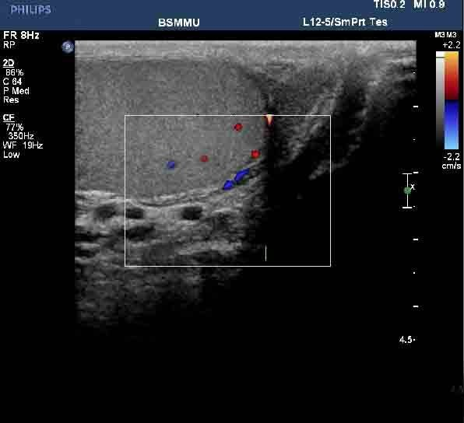

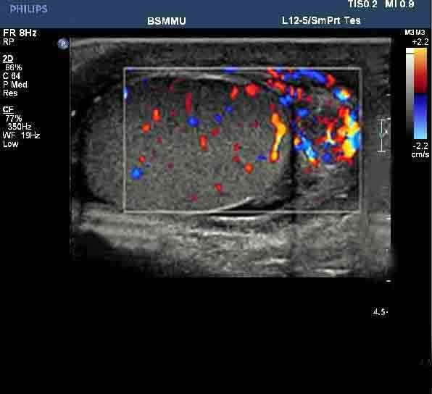**Figure 1: Normal Tesitis-Color Doppler scan showing echogenicity & vascularity of normal testis.**

**Figure 2: Epididymo-orchitis- Color Doppler scan showing enlarged testis with increased vascularity.**

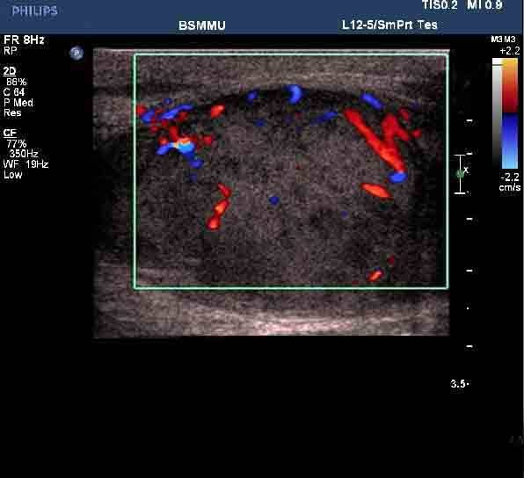

**Figure 3: Testicular Tuberculosis-Color Doppler scan showing heterogeneous testis with increased vascularity.**

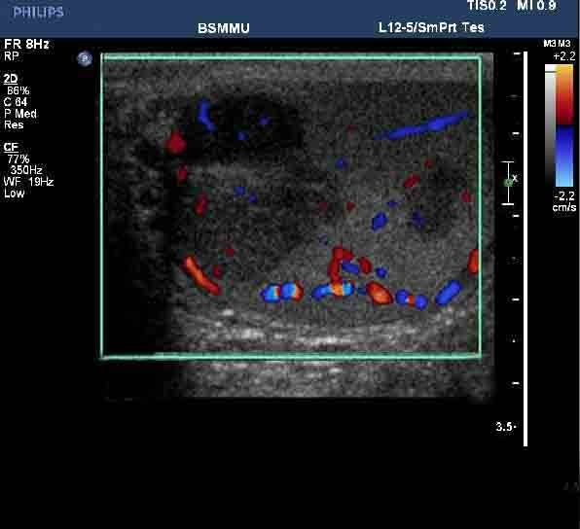

**Figure 4: Testicular Seminoma-Color Doppler scan showing multiple hyphoechoic testicular lesions with increased vascularity.**

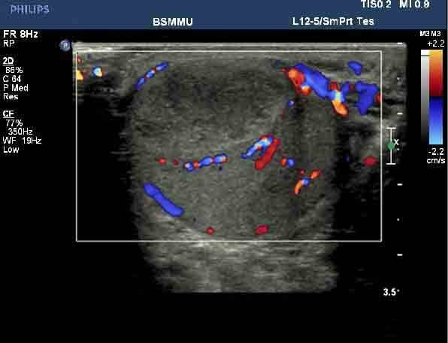

**Figure 5: Testicular abscess-Color Doppler scan showing mixed echogenic testis with increased peripheral vascularity.**

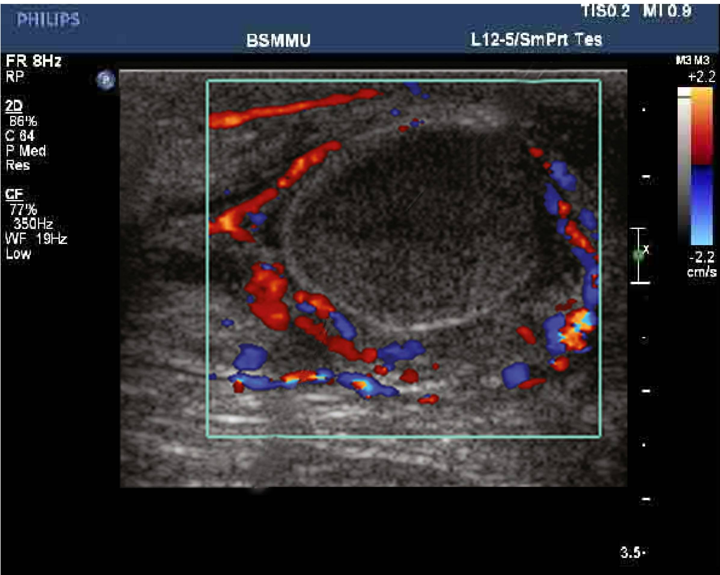

**Figure 6: Testicular torsion- Color Doppler scan showing absent vascularity within testis with increased peripheral vascularity.**